

BSc Hons in Computing
2024.2
An Explainable Multi-Source Spatiotemporal Model for Traffic Accident Hotspot Prediction and Severity Classification in Sri Lanka

Coventry Index : 16114760
NIBM Registered Name : L.P.N.R.R. Pathirana
NIBM Index : COBSCCOMP24.2P-053

Faculty of Engineering, Environment and Computing
School of Computing, Electronics and Mathematics
Coventry University

School of Computing and Engineering
National Institute of Business Management

Abstract
This research develops an explainable multi-source spatiotemporal machine learning framework for traffic accident hotspot prediction and severity classification that addresses the Sri Lankan context. The study was motivated by rising traffic concerns in Sri Lanka and limitations of current studies such as dependence on single data sources, limited exploration of spatiotemporal analysis and lack of XAI integration into such frameworks. Accordingly, synthetic accident records were generated based on Sri Lankan empirical sources related to road accidents due to the lack of a proper accident data management system. Such data were then merged with weather data obtained from Visual Crossing Weather API and indexed into H3 cells, allowing spatiotemporal analysis. Then Logistic Regression, Random Forest and XGBoost were trained and evaluated using a leakage-safe temporal validation approach. Once models were trained and evaluated, one candidate model for each predicition task was chosen and integrated with SHAP TreeExplainer. Accordingly, Random Forest was chosen for hotspot prediction and XGBoost for severity classification. Finally, predictions and SHAP explanations were visualized through a prototype dashboard as a demonstration of the framework. However, such outputs must be interpreted within the DSR Lambda contribution, as the study only focused on demonstrating reusable framework rather than claiming ground truth. This is mainly because of the use of synthetic data due to the lack of a proper centralized data management system in the Sri Lankan context. However, future studies can extend this framework from a proof of concept to real world deployment by using real world accident records.
Keywords: Traffic accident hotspot prediction, Severity classification, XAI, SHAP, Spatiotemporal analysis, Machine learning, Sri Lanka

Contents
Abstract ii
Chapter 1: Introduction 1
1.1 Background 1
1.2 Research Problem 4
1.3 Objectives of the Project 6
1.4 Research Questions 6
1.5 Scope of the Research 7
1.6 Justification of the Research 8
1.6.1 Social Justification 8
1.6.2 Economic Justification 9
1.6.3 Technological Justification 9
1.7 Expected Limitations 10
1.7.1 Data Limitations 10
1.7.2 Time Limitations 10
1.7.3 Geographic Limitations 10
1.7.4 Validation and Contribution Limitations 11
1.8 Chapter Summary 12
Chapter 2: Literature Review 13
2.1 Introduction 13
2.2 Theoretical Background and Conceptual Explanation of Key Concepts 14
2.3 Empirical Review of Previous Studies 18
2.3.1 Machine learning approach to traffic accident analysis and hotspot prediction 18
2.3.2 Crash Severity Prediction and Hotspot Identification using Machine Learning and Spatial Analysis 19
2.3.3 Machine learning approach for classifying road accident hotspots 20
2.3.4 Sri Lankan Accident Hotspot and Severity Prediction Model 21
2.3.5 Explainable AI traffic accident analysis and hotspot prediction 22
2.3.6 Spatiotemporal Risk Mapping of Statewide Weather-related Traffic Crashes: A Machine Learning Approach 23
2.4 The Research Gap 24
2.5 Summary of the Findings 26
2.6 Chapter Summary 28
Chapter 3: Methodology 29
3.1 Introduction 29
3.2 Research Philosophy 31
3.3 Research Approach 33
3.4 Design Science Research Methodology 34
3.4.1 Problem Identification 34
3.4.2 Solution Design 34
3.4.3 Development 35
3.4.4 Evaluation 35
3.5 Research Process 36
3.6 Requirement Gathering 37
3.6.1 Requirements from Literature Review and Research Gaps Analysis 37
3.6.2 Requirements from Identified Practical Limitations 39
3.7 Data Collection 40
3.7.1 Historical Police Accident Records 40
3.7.2 Weather Data 45
3.8 Hotspot Identification and Spatiotemporal Feature Engineering 47
3.8.1 Spatial Indexing via H3 (your H3 text and the resolution 8 choice) 47
3.8.1 Hotspot Identification Criteria (the Poisson and Benjamini–Hochberg part) 48
3.8.3 Causal Rolling Spatiotemporal Features 50
3.9 Software Development Methodology 52
3.10 Artefact Evaluation Strategy 53
3.9.1 Synthetic data Validation 53
3.9.2 Framework Validation 55
3.9.3 Threats to Evaluation Validity 55
3.11 Research Validity and Reliability 56
3.10.1 Research Validity 56
3.10.2 Research Reliability 58
3.12 Ethical Considerations 59
3.13 Chapter Summary 61
Chapter 4: Proposed Solution 63
4.1 Introduction 63
4.2 Requirement Analysis 64
4.2.1. Functional Requirements 64
4.2.2 Non-Functional Requirements 65
4.3 Proposed Solution 66
4.4 System Architecture 67
4.5 System Design 70
4.5.1 Use Case Diagram 70
4.5.2 Class / Data Scheme Diagram 70
4.5.3 Activity Flow Diagram 71
4.5.4 User Interfaces 72
4.6 Algorithms/Models 74
4.6.1 Algorithms 74
4.6.2 Models 75
4.7 Dataset / Data Preparation 76
4.8 Technology Selection 78
4.9 Implementation 79
4.10 Chapter Summary 81
Chapter 5: Evaluation and Results 82
5.1 Introduction 82
5.2 Evaluation Framework 83
5.3 Evaluation Criteria 84
5.4 Experimental/Test Results 85
5.5 System Performance Results 87
5.6 Synthetic Data Evaluation 88
5.7 Accuracy/Precision/Recall or Other Technical Measures 89
5.6.1 Hotspot Classification Results based on Temporal Test Window 89
5.6.2 Severity Classification Results based on Temporal Test Window 90
5.8 User Evaluation 91
5.9 Usability Evaluation 91
5.10 Comparison with Existing Solutions 92
5.11 Results Related to Research Objectives 93
5.12 Chapter Summary 94
Chapter 6: Discussion, Conclusion and Recommendations 96
6.1 Introduction 96
6.2 Discussion of Findings 96
6.3 Achievements of Research Objectives 98
6.4 Answers to Research Questions 99
6.5 Recommendations 100
6.6 Future Research 102
6.7 Conclusion 103
6.8 Chapter Summary 104
References 105
Appendix A – Hotspot Classifier Results 112
Appendix B – Severity Classifier Results 117
Appendix C - Links 122

Table of Figures

Figure 1 Overview of Methodology 31
Figure 2 Sample Records from Slave Island Police Station 42
Figure 3 Synthetically Generated Data for Model Training 46
Figure 4 Weather Data Collected via Visual Crossing API 47
Figure 5 System Architecture 70
Figure 6 Use Case Diagram 71
Figure 7 Class Diagram 71
Figure 8 Activity Flow Diagram 72
Figure 9 Accident Hotspot Prediction and Severity Classification Dashboard 73
Figure 10 Hotspot Prediction Probability and SHAP Explanations 73
Figure 11 Severity Prediction Probability and SHAP Explanations 74
Figure 12 Hotspot Identification Algorithm 75
Figure 13 Random Forest (Hotspot Classifier) 76
Figure 14 XGBoost (Severity Classifier) 77
Figure 15 Comparison with Existing Solutions 94
Figure 16 Random Forest Feature Importance for Hotspot Prediction (Top 15 Features) 113
Figure 17 Summary Plot of the Random Forest Hotspot Classifier on the Temporal Test Window (September–December 2023) 114
Figure 18 ROC Curves of the Hotspot Classifiers on the Temporal Test Window 114
Figure 19 Precision–Recall Curves of the Hotspot Classifiers on the Temporal Test Window 115
Figure 20 Train and Test F1-Score of the Hotspot Classifiers on the Temporal Split 115
Figure 21 Train and Test Accuracy of the Hotspot Classifiers on the Temporal Split 116
Figure 22 XGBoost Log Loss and Accuracy per Boosting Round on the Temporal Split 116
Figure 23 Random Forest Accuracy and F1-Score by Number of Trees on the Temporal Split 117
Figure 24 Logistic Regression Learning Curves on the Temporal Split (Expanding Monthly Training Window) 117
Figure 25 A11 XGBoost Feature Importance for Severity Classification (Top 15 Features) 118
Figure 26 Mean Absolute SHAP Values by Severity Class for the XGBoost Severity Classifier on the Temporal Test Window 118
Figure 27 Confusion Matrices of the Severity Classifiers on the Temporal Test Window 119
Figure 28 Per-Class F1-Score of the Severity Classifiers on the Temporal Test Window 119
Figure 29 One-vs-Rest ROC Curves of the XGBoost Severity Classifier on the Temporal Test Window 120
Figure 30 Train and Test Macro-F1 of the Severity Classifiers on the Temporal Split 120
Figure 31 Train and Test Accuracy of the Severity Classifiers on the Temporal Sp 121
Figure 32 XGBoost Multiclass Log Loss and Accuracy per Boosting Round on the Temporal Split 121
Figure 33 Random Forest Accuracy and Macro-F1 by Number of Trees for Severity Classification 122
Figure 34 Logistic Regression Learning Curves for Severity Classification (Expanding Monthly Training Window) 122

List of Tables

Table 1 Summary of Findings 27
Table 2 Empirical Sources 43
Table 3 Functional Requirements 66
Table 4 Non-Functional Requirements 67
Table 5 Empirical Sources 79
Table 6 Technology Selection 80
Table 7 Evaluation Criteria 86
Table 8 Test Results 88
Table 9 System Performance Results 89
Table 10 Synthetic Data Evaluation 90
Table 11 Hotspot Classification Results 91
Table 12 Severity Classification Results 91
Table 13 Heuristics Usability Evaluation 93

Chapter 1: Introduction

1.1 Background
Each year road traffic accidents cause significant damage to human lives and economy. Accordingly, World Health Organization reports that around 1.19 million loses their life as a result of road traffic accident while causing significant number of injuries to individuals. and damages to properties (World Health Organization, 2023). Not only that, but such accidents can also cause economic burden to both the individuals and economy of a relevant country via healthcare expenses, property damage, emergency response cost and etc. (Tandrayen-Ragoobur, 2024).

As a country, Sri Lanka also records a gradual increase in vehicle accidents each year due to factors like urbanization and increased number of vehicle usage. According to the Police Spokesman ASP F.U. Wootler, the number of deaths caused by accidents has increased by 322 compared to 2024, recording 2710 death in the year 2025 (Dailymirror, 2026). Also similar to other countries, road traffic accident has a significant impact to Sri Lankan economy as well. According to a study by Bhavan (2019), it is found that 1% increase in fatality index can negatively affect the country by declining its economic growth by 0.79%. Additionally, the study by Bhavan (2019) also confirms that road traffic accident contributes to increased health expenditures per capita, placing further restrains on financial resources. This confirms that road traffic accident cause harm not only to individual but also cause damage to the country’s macroeconomic stability.

To reduce negative impacts of road traffic accidents, Sri Lankan government has already taken necessary steps such as introduction of new laws, polices, awareness programs and etc. (Ministry of Transport, n.d.). However, even with such measures, the number of road traffic accidents fluctuates each year due to numerous factors like poor road conditions, reckless driving and excessive speeding (Over 670 Fatal Road Accidents Reported so Far This Year - Sri Lanka Police, 2026). Accordingly, it is clear that such traditional reactive measures alone are not effective, when it comes to road traffic accident preventions in modern Sri Lanka.

However, advancements in computing technologies such as data analytics and machine learning have enabled us with developing predictive frameworks to minimize road traffic accidents. Existing studies have already incorporated machine learning technologies to implement data driven predictive strategies to minimize road traffic accidents. But exploration of such data driven frameworks are extremely limited when it comes to Sri Lanka where accident contributing factors significantly differ from those countries.

Additionally, just incorporating machine learning in safety critical domain has its own problems. One major problem is machine learning model itself are black box systems. This lack of transparency makes it difficult for authorities to incorporate such technologies for accident hotspot prediction. For example, when it comes to safety critical domain such as transportation and road traffic accident, relevant authorities need to know why a certain model made a certain prediction about accident hotspots. However, Explainable Artificial Intelligence frameworks such as SHAP can be incorporated to improve model’s interpretability and thereby it’s transparency (IBM, 2023).

Furthermore, road traffic accidents are cause by combination of factors such as weather data, geographical factors, spatial and temporal events. Among those, existing studies found that weather data play a major role in road traffic accidents. For example, adverse weather conditions such as heavy rainfall, reduce visibility and fog may increase the risk of road traffic accidents (Gorzelanczyk, 2025). It is also found that integrating such contextual weather data can improve a model’s prediction accuracy.

In addition to above discusses factors, road traffics accidents are also not uniformly distributed across locations and time periods. They vary depends on those spatial and temporal features (Wondwossen Taddesse Gedamu et al., 2025). For example, certain location may prone to more accidents during certain time periods or during certain seasonal trends. So, it is very important for authorities to understand how road traffic accident evolves across locations and time periods along with generic accident hotspot prediction. This can be achieved via spatial temporal analysis of accident data, which also improves accident hotspot prediction and severity classification

Accordingly, this research proposes developing of a multi-source machine learning framework for accident risk prediction and spatial analysis in Sri Lanka, which will be integrated with Sri Lankan police accident records and contextual weather data. This framework will help decision making process of the relevant authorities by identifying accident hotspot locations, contributing factors for the accident prediction, dynamic variations across accidents hotspots over a period of time and presenting those information via an interactive dashboard.

1.2 Research Problem
As mentioned earlier, it is very clear that road traffic accidents pose a significant global threat to both human lives and economy of a country. Like every other country Sri Lanka also deals with such negative impacts of road traffic accidents each year. Despites traditional measures such as traffic laws, fines, and signal systems taken by Sri Lankan government to minimize road traffic accidents, statistics shows that number of accidents fluctuates each year with a significant increase in number of road accidents in recent years (Department of Census and Statistics, 2024).

However, with the recent advancements in computing technologies such as predictive analysis using machine learning researchers have already explored using such technologies for accident hotspot prediction and analysis and thereby to enable implementation of predictive framework to minimize road traffic accidents. One of the best examples for this is study done by de et al. (2023), where they developed a predictive framework for accident hotspot prediction in Brazilian Highways using multiple data sources such as location, time and weather conditions. But exploration of such kind of machine learning frameworks are extremely limited when it comes to Sri Lankan context. Moreover, frameworks developed for countries like Brazil are not validated against Sri Lankan context where accident contribution factors such as weather, peak hours and traffic conditions significant differ from such countries.

When it specifically comes to Sri Lankan context, only a limited number of studies have been done on this exact domain. Accordingly, Jayamanna and Kalansooriya (2024) have explored on implementing a machine learning based system that can predict accident hotspots using historical police accident records. But that study was only limited to police accident data source and given no focus when it comes to integrating contextual data sources such as weather data where such contextual data can improve the model’s prediction performance significantly (Yan & Shen, 2022). Accordingly, there is a need for developing a machine learning framework with multiple data sources for Sri Lankan context.

Also as mentioned earlier, occurrence of road accidents are not uniformly distributed across locations and time periods and they vary depends on the location (spatial) and temporal (time) features. So, understating such variation can be very helpful for authorities when it comes to decision making and implementing preventative strategies related to road traffic accidents. Additionally, analysis of such spatial and temporal variation can contribute greatly to the model’s performance (Yan & Shen, 2022). However, to best of my knowledge there are no existing studies have been done on this spatial and temporal analysis when it comes to Sri Lankan context.

As mentioned earlier, another major problem is lack of transparency among machine learning models. As a result, safety critical domains such as transportation hesitate to incorporate machine learning predictive frameworks for accident hotspot prediction and severity classification. However, such issues can be addressed by integrating Explainable AI technologies to machine learning framework as these technologies helps to understand contribution of features to a certain prediction (Al-Omari et al., 2025). But, similar to spatial and temporal analysis of road traffic accident-related data, only a limited number of evidence was found regarding incorporating Explainable AI technologies for accident hotspot prediction and severity classification in Sri Lankan context.

Accordingly, Sri Lanka needs a machine learning framework that uses multiple data sources such as police accident data and weather data for accident hotspot prediction and severity classification. Additionally incorporating analysis of spatial and temporal variation in accident related data Explainable AI technologies can improve both model’s prediction accuracy and transparency.

1.3 Objectives of the Project
- To feature engineer the spatial, temporal and weather parameters from the combined accident data and weather data for the development of spatiotemporal model training panel.
- To train and evaluate Logistic Regression, Random Forest and XGBoost to identify a candidate model for hotspot prediction and severity classification tasks.
- To integrate Explainable AI techniques into prediction pipeline as it helps to improve transparency and interpretability of predicted results
- To design and develop a complete reusable machine learning framework for traffic accident hotspot prediction and severity classification

1.4 Research Questions
- How can spatial, temporal, and weather features be engineered from accident and weather data to develop a spatiotemporal model training panel?
- What is the best machine learning model among Random Forest, Logistic Regression, XGBoost, when it comes to accident hotspot prediction and severity classification?
- How can Explainable AI techniques be integrated into the prediction pipeline to understand feature contribution to a certain prediction and thereby to improve the transparency and interpretability of the framework?
- How can a reusable machine learning framework be designed and developed for traffic accident hotspot prediction and severity classification?

1.5 Scope of the Research

The main objective of the research is to develop a multi source explainable machine learning framework for accident hotspot prediction and severity classification in Sri Lanka along with analysis of dynamic variations across accident hotspots using spatial and temporal analysis of road accident data. For the implementation, historical police accident records along with weather data obtained through external APIs based on accident location, time and data will be used. Also the scope of this research will be limited to a selected set of regions due to data scarcity in Sri Lankan context.

The inputs for this research include accident related data such as location, date and time, severity, vehicle involvement, casualties, and cause of the accident along with the contextual weather data, which includes features like precipitation, visibility and temperature. Once collected, these data will go through an ETL pipeline where preprocessing techniques like extraction, transformation, feature engineering and finally integrating to a centralized data warehouse happen. After this, these data will be used to train and evaluate machine learning models such as random forest, Logistic Regression and XGBoost to identify the most suitable for Sri Lankan context.

The final output of the research will be a prototype dashboard and an API with only core functionalities needed for visualization of predicted hotspot location along with location based filtering and meta data insights that support decision making.

Additionally, this framework is developing for authorities such as traffic police authorities and road safety analyst who can use the system to identify hotspot prone areas, contributing factors for predicted accidents and thereby to support data driven decision making.

Also, it is very important to note that this research will be limited only to historical data of selected regions, mainly Colombo Municipal Area as there is no any systematic approach to obtain real time or livestream accident data within Sri Lanka.

1.6 Justification of the Research

1.6.1 Social Justification
As mentioned earlier, road traffic accidents have a significant impact on society in Sri Lanka. Accordingly, each year considerable number of people either suffer from disabilities, serious injuries or even losses their lives due to road accidents. For example, more than 2500 deaths were caused due to road traffic accidents and more than 150000 casualties were receiving in patient treatment due to road traffic accidents in the year 2024 (Siritunga, 2025).

Even though, Sri Lankan government has taken some preventative measures such as traffic laws, awareness programs and other traditional measures to reduce those road traffic accidents, still the impact of road traffic accidents towards social life of Sri Lankans has not significantly reduced. This is because most of such preventative strategies are reactive approaches rather than being proactive approaches. However, our proposed framework helps to identify such accident hotspot and severity of them early, enabling relevant authorities with enough time to take necessary actions such as deploying enough traffic officers, positioning emergency medical services, implementing safety intervention etc. Accordingly, such actions can lead to reduction of number of road traffic accidents and its impact on Sri Lankan society.

1.6.2 Economic Justification
In addition to above mentioned impacts that negatively affects society, road traffic accident also poses a threat to individuals and country’s economy. For example, those accident can cause negative economic impacts such as increased expenses in healthcare and emergency services, vehicle and other property damages, productivity losses due to disabilities and even traffic congestion that can affect supply chain and overall day to day life of people. Also, according to World Bank, it is mentioned that Sri Lanka will need additional USD 2 billion investment by 2030, just to manage road deaths by half and such road traffic accidents can cost around 3-5% of country’s GDP (Siritunga, 2025). However, by predicting accidents earlier with their severity, relevant authorities can take necessary actions earlier to reduce the impact of such accidents and thereby to reduce the above-mentioned negative impacts that affects both directly and indirectly towards individuals and country’s economy.

1.6.3 Technological Justification
When it comes to technological side of the research, most of the existing studies in Sri Lanka has only given focus to accident hotspot and severity prediction with limited exploration towards integration of technologies such as multiple-data source, spatiotemporal analysis, and Explainable AI integration. However, to mitigate such limitations, this research proposes an explainable multi source spatiotemporal framework for hotspot prediction and classify severity of them. Furthermore, even most of the existing studies that integrated Explainable AI only shows the contribution of features to a certain prediction. Even though XAI integrations improves the model’s transparency, such kind of frameworks are still unable to provide intelligent context aware recommendations to the relevant authorities to make the decision making process easier. Accordingly, through the proposed framework, we also address those kinds of limitation by adding a multi agent decision support system and thereby improving practicality of the framework.

1.7 Expected Limitations

1.7.1 Data Limitations
One of the major expected limitations of this research is the limited access to relevant historical traffic accident data within Sri Lanka. Unlike, well developed countries where such data are stored on centralizes data management systems, Sri Lanka manage most of these data still via physical records. Also, most of the records in those physical records were incomplete, inconsistent, and written using Sinhala language, making the data collection process both harder and time consuming. As a result of this limitation, only a very limited number of data were able to collect from Slave Island police station.

1.7.2 Time Limitations
As mentioned above, Sri Lanka still manages traffic accident related via physical records and collection of such data requires a manual effort to go through records books and extracting relevant information. Not only that, but the records were also written in Sinhala language which require additional effort to read handwritten materials and converting them to tabular format which machine learning models understand. However, with the given limited time to complete both the dissertation and artefact, it is unable to invest too much of time just for the data collection phase, which justifies the need for synthetic data. In addition to those, model evaluation is also limited for 1 base model and 2 ensemble model due to this time constraint.

1.7.3 Geographic Limitations
Another major limitation of this research is that is geographically limited to Colombo Municipal Area as result of not having enough data due to previously mentioned data limitations. However, it is supposed to generate synthetic data based on the collected data to address the data limitation issue and to make sure that the framework itself technically works (Lambda Contribution) rather than presenting finding of real-world insights (Omega Contribution) (Gregor & Hevner, 2013). But even those synthetic data is also limited to Colombo Municipal Area as such synthetic data is based on Colombo area’s road network, weather patterns and location structure. So it is better to understand that even technical feasibility (Lambda Contribution) of the framework is implemented by considering Colombo Municipal Area context.

1.7.4 Validation and Contribution Limitations
Another limitation is that Sri Lanka does not have any publicly available traffic accident hotspot or blackspot location maintained by official authorities like Sri Lanka Police. As a result of this, there is no any structured way to validate the findings of the research against official source. So considering factors like data limitations, geographic limitations, validation limitations and most of historical traffic accident data that is supposed to use for model training being synthetic, contribution of the research will be limited to technical aspect (Lambda Contribution) rather than statistical insights or real world accuracy of the predicted hotspots (Omega Contribution) (Gregor & Hevner, 2013).

1.8 Chapter Summary
In today’s world, road traffic accidents are considered as one of the major global threats to both human lives and economy of a country. As a country Sri Lanka also experiences negative effects of road traffic accidents due to several factors such as urbanization, increased vehicle usage and etc. Despites the traditional measures such as implementation of laws and regulations, traffic light systems, awareness programs, fine taken by Sri Lankan government, the number of road traffic accidents grow each year.

However, this chapter introduces our research which uses computing technologies such as machine learning and data analytics to address issues of traditional measures taken to minimize negative effects of road traffic accidents. Additionally, it also explores the usage of Explainable AI technologies along with machine learning models to improve their transparency and thereby to reduce difficulties in adapting such technologies in safety critical domain such as transportation and road traffic accidents.

Furthermore, this chapter also highlights, how such implementation are minimally adapted when it comes to Sri Lankan context, along with an overview of limitations of existing studies.

In conclusion this chapter introduces the proposed explainable multi-source spatiotemporal model for traffic accident hotspot prediction and severity classification in Sri Lanka along with its objectives, research questions and scope of the research. The next chapter will explore existing literatures related to accident hotspots prediction, machine learning, techniques used in hotspot predictions, spatiotemporal modelling and explainable AI technologies along with identification of research gaps on existing studies in related to our proposed implementation.

Chapter 2: Literature Review

2.1 Introduction
As mentioned earlier, road traffic accidents pose a significant threat to human lives and economy of a country. However, researcher have found that it is possible to use computing technologies like machine learning to minimize road traffic accident effectively and efficiently. By using such technologies, it is possible to implement system that can perform tasks like accident hotspot prediction and such implementations can greatly contribute to decision making by authorities, enabling them to take both preventative and effective actions to minimize road traffic accidents.

Accordingly, this chapter will analyze existing studies related to accident hotspot prediction and severity classification using technologies like machine learning, multi-source data integration, Explainable AI, Spatial and Temporal Analysis in related to both global and Sri Lankan context. Furthermore, a comprehensive explanation about research gaps that is found via exploring current studies will also be included in this chapter.

2.2 Theoretical Background and Conceptual Explanation of Key Concepts

2.2.1 Machine learning
Usually, in order to enable computers with decision making capabilities, we have to program every possible scenario related to a certain decision making process via rule based algorithmic techniques. However, with the invention of machine learning (ML), which is a subsection of Artificial Intelligence (AI), it is possible to enable such computer systems to make predictions or decisions by making those computers learn patterns, relationships and structures via historical data without needing the above mentioned rule based algorithmic approaches (Chen, 2024).

Furthermore, machine learning is divided in to 3 approaches, which are namely, supervised, unsupervised and reinforcement learning. Accordingly, when it comes tasks like predicting traffic accident hotspots, it is found that supervised learning is much more suitable as these kinds of tasks require involve learning patterns in historical road traffic data via input variables (features) and output variables (target) (Chen, 2024).

When it comes to using supervised learning approach in this study, it acts as classification task instead of regression as the goal is to label a certain spatial and temporal unit as either a hotspot or not. Also, similar approach has been used when it comes to predicting severity of each hotspot based on the predefined severity assigned to each road accident.

2.2.2 Spatiotemporal Analysis
Events like occurrence of traffic accident depends heavily on geographic locations and the time of the day. However, most of the existing studies implement these kinds of frameworks by considering geographic locations/space (spatial) and time (temporal) as 2 separate entities, which can lead to incomplete predictions. As a solution for this, we can incorporate techniques like spatiotemporal analysis which helps us to understand how patterns related to events like occurrence of road traffic accident hotspots changes with the time and geographic locations (Turab et al., 2026).

Like mentioned earlier, road traffic accidents are not uniformly distributed across geographic locations and time. Instead, many factors like traffic conditions, date, time of the day, weather during the occurrence of the accident, and even historical trends contribute to occurrence of such accident. Therefore, considering only one among spatial and temporal changes can lead to missing detail in each other. Accordingly, by using spatiotemporal analysis, we can enable a machine learning model to learn patterns across both space and time, instead of making it to consider accidents as static events.

Accordingly, when it comes to this study, it implements spatiotemporal analysis via considering factors like time trends related to road accidents, environmental or weather features, and even by creating spatial units via Uber’s H3 Spatial Indexing.

2.2.3 Explainable Artificial Intelligence (XAI)
As mentioned earlier, machine learning can be really good when it comes to predictive performance. However, despite being good at prediction, those machined learning models are considered as black box systems as a result of difficulties in understanding the decision making process of such models by humans. This limited transparency can result in limited adaptation of such technologies in safety critical areas like transportation. As a solution for these kinds of problems Explainable AI (XAI) techniques has been introduced (Ali et al., 2023).

Accordingly, by using XAI, we can understand how a certain prediction is made by a machine model and what input features contributed most for that prediction. Techniques like these, improve the model interpretability and thereby their transparency which helps to improve their adaptation in safety critical domains (Ali et al., 2023).

The specific XAI techniques that we use for this study is SHapley Additive exPlanations (SHAP) which is based on Shapely values from cooperative game theory. Accordingly in this method each feature’s contribution to certain predication is calculated by observing how the prediction of a machine learning changes when features of a dataset added or removed across all possible combinations (Lundberg & Lee, 2017). Moreover, SHAP can provide both global feature explanation, which helps us to understand overall feature importance of the whole dataset and local feature explanation, which helps us to understand each feature’s contribution to a certain predication.

Accordingly when it comes to this study, SHAP is used to understand how feature like spatiotemporal and weather condition contributed to a certain accident hotspot and severity prediction, improving adaptation of such frameworks in safety critical domains such as transportation.

2.2.4 Lambda (Λ) and Omega (Ω) Contribution in Design Science Research (DSR)
Traditional research mostly focuses on understanding or explaining existing phenomena. But when it comes to Design Scient Research (DSR), it involves design, development and evaluation of an artefact that can be used to solve a specific social or organizational problem. Accordingly, this research methodology helps to output a artefact along with proof that the relevant artefact is rigorously evaluated while ensuring its relevance to practical world.

When it comes to DSR project, it can be classified into 2 parts as Lambda (Λ) and Omega (Ω) based on its knowledge contribution. Accordingly, Lambda (Λ) contribution is more focused on delivering technical designs, development, and evaluation of a certain artefact and its more about proving that the relevant artefact can be implemented technically to solve a specific problem. Overall lambda contribution is about outputting a methodological rigorous artifact that is novel, technical feasible and being a product that can solve a real-world problem rather than proving its impact via findings (Gregor & Hevner, 2013).

On the other hand, Omega (Ω) contribution is more focused on real world impact and insights that can be gained after a certain artefact is deployed in a relevant working environment. Unlike lambda contribution which only shows certain artefact can be developed using the method that describe in the dissertation, Omega contribution requires proving the developed artefact can provide real world insights via the output of the artefact and improves organization performance, which requires additional evaluation to make sure that such insights are authentic (Gregor & Hevner, 2013).

When it comes to this study, its more focused on lambda contribution due to some limitation like data scarcity, usage of synthetic data generation and external validation via the organizations like Sri Lanka police itself. As a result of these limitation, this study is going to give lesser or no focus for omega contributions. However, the study will output an artefact that can predict traffic accident hotspots and severity via the usage of technologies like machine learning, XAI, and spatiotemporal analysis that is rigorously tested and evaluated for Sri Lankan context, ensuring a Lambda contribution.

2.3 Empirical Review of Previous Studies

2.3.1 Machine learning approach to traffic accident analysis and hotspot prediction
When it comes to traffic accident analysis and hotspot prediction Santos et al. (2021) has explored using combination of both supervised and unsupervised machine learning technologies for road accident analysis and hotspot prediction in Setúbal district of Portugal.

Accordingly, when it comes to supervised models, Santos et al. (2021) have used several classification technologies such as Decision Trees, Random Forest, Logistic Regression, and Naïve Bayes. Among them, it is found that Random Forest performs better when it comes to accident hotspot prediction. In addition to these classification algorithms, Santos et al. (2021) have also used unsupervised technologies such as Hierarchical Clustering and Density-Based Spatial Clustering of Applications with Noise (DBSCAN) to identify accident prone location clusters. Accordingly, it found that DBSCAN works effectively when it comes to identifying accident prone location clusters.

Furthermore, comparison of multiple machine learning models can be considered as a major strength as in enables evaluation of their performance in accident hotspot prediction. Moreover, it shows that ensemble models such as Random Forest performs well, when it comes to road traffic accident hotspot prediction, enabling us to choose it as a candidate model for our research.

However, this study was conducted in Portugal, which may limit its adaptability when it comes to Sri Lankan context. Also, the study has given limited focus when it comes to Explainable AI techniques and Spatiotemporal modelling of road accident-related traffic data, leaving gaps in implementing such features.

2.3.2 Crash Severity Prediction and Hotspot Identification using Machine Learning and Spatial Analysis
Islam et al. (2022) have also explored on traffic accident hotspot and severity prediction using supervised machine learning approaches. Accordingly, this research was based on Al-Ahsa region of Saudi Arabia. Also, in addition to machine learning approached, researchers have also incorporated Geographic Information System (GIS) based spatial analysis.

Researchers have trained and evaluated 3 supervised machine learning approaches for severity prediction, namely Random Forest, XGBoost, and Logistic Regression. Among them, it is found that Random Forest performed best in their context, achieving 94% accuracy. This study again demonstrates efficiency of supervised machine learning approaches for hotspot and severity prediction. Furthermore, in addition to severity prediction, this study has incorporated Geographic Information System (GIS) based spatial analysis techniques such as Global Moran’s I and Getis-Ord 𝐺∗𝑖 for hotspot identification. Accordingly, results of such analysis highlights that the occurrence of road traffic accidents are based on specific locations with higher risk.

Accordingly, this research shows the importance of combining machine learning models with spatial techniques for severity prediction and hotspot identification and how such framework can benefit transportation authorities in decision making and redcuing road traffic accidents.

However, this research is also limited Saudi Arabian context and not validates against Sri Lankan context. Moreover, usage of Explainable AI techniques and analysis of temporal patterns are highly under explored, leaving gap in combining spatiotemporal analysis along with Explainable AI for accident hotspot prediction and severity classification (Islam et al., 2022).

2.3.3 Machine learning approach for classifying road accident hotspots
de et al. (2023) have already conducted research for identifying road traffic accident locations using supervised machine learning approaches. Additionally, they have also used contextual variables such as weather data that may contribute to traffic accidents.

When it comes to supervised machine learning approaches, de et al. (2023) have used Support Vector Machine (SVM), Random Forest, XGBoost, and Artificial Neural Networks (ANNs) and it is found that ANN performed best with a balanced dataset. Overall researcher highlights that supervised machine learning approaches are effective when it comes to identification of accident hotspots using a balance dataset.

Another strength of this research is the incorporation of external variables such as weather data. Accordingly, it is found that incorporating such variables can improve model’s prediction performance and this proves that same concept can be applied when it comes to Sri Lankan context as such approaches remain underexplored.

Additionally, this study was also given limited focus when it comes to integrating Explainable AI techniques and implementation of frameworks like this are underexplored in Sri Lankan context where weather patterns and peak hours significantly differ from those countries, leaving a gap in adapting such technologies in Sri Lankan context (de et al., 2023).

2.3.4 Sri Lankan Accident Hotspot and Severity Prediction Model
As mentioned earlier only a limited number of studies have been conducted on traffic accident hotspot prediction. One of such studies are a study done by J.M.C.T. Jayamanna & P. Kalansooriya (2024), where they developed a machine learning based mobile application for accident hotspot prediction and severity classification using supervise machine learning approaches.

Accordingly, regression supervised machine learning approaches such as Random Forest Regression, Support Vector Regression (SVR), Gradient Boosting Regression, Decision Tree Regression, and XGBoost Regression were used and evaluated. Among them based on metrices such as Mean Squared Error (MSE) and Mean Absolute Error (MAE), XGBoost Regression was identified as the model with the best performance and chosen as the candidate model for accident hotspot prediction.

When it comes to severity classification, approaches such as Random Forest, XGBoost, and Multi-Layer Perceptron (MLP) classifiers have been used and evaluated using metrices such as accuracy, precision, recall and F1-score. Accordingly, it is found that Random Forest classifier perform best when it comes to accident severity prediction with an accuracy of 68%.

However, this research was highly limited to a single source historical dataset which was obtained from Mount Lavinia police station. Additionally, this study has given a limited focus when it comes to integrating contextual data sources such as weather data which can improve model’s prediction performance. Furthermore, Explainable AI techniques and spatiotemporal analysis of accident data were severely underexplored, leaving a gap in developing multi source framework with Explainable AI technologies such as SHAP and spatiotemporal analysis for accident hotspot prediction and severity classification in Sri Lanka (J.M.C.T. Jayamanna & P. Kalansooriya, 2024).

2.3.5 Explainable AI traffic accident analysis and hotspot prediction
Even though machine learning models can perform predictions related to certain task, it fails to explain how the prediction is made. This is because machine learning models act as black box systems, limiting their adaptability in safety critical domains such as transportation and road traffic accidents due to limited transparency and interpretability. However, to mitigate these kinds of issues researcher have explored on integrating Explainable AI techniques with road accident hotspot prediction systems.

Accordingly, Al-Omari et al. (2025) have explored on integrating Explainable AI technique called SHapley Additive exPlanations (SHAP) with Random Forest to develop a interpretable machine learning model for road accident severity analysis for Irbid region of Jordan. By using SHAP, it is possible to quantify the contribution of each feature for a prediction and thereby to understand the prominent features affecting final accident severity prediction. Accordingly, it is found that speed was the feature that contributed mostly to the traffic accident severity analysis among several environmental and traffic accident-related features.

Accordingly, this study shows the potential of integrating Explainable AI techniques such as SHAP for traffic accident hotspot prediction related tasks. As such integrations, improve model transparency and interpretability by explaining why a certain prediction is made, the relevant users of the system can make informed decisions.
However, such frameworks are also not validated against Sri Lankan context where contribution factors may differ from countries like Jordan, leaving a gap in incorporating such techniques for accident hotspot prediction in Sri Lanka.

2.3.6 Spatiotemporal Risk Mapping of Statewide Weather-related Traffic Crashes: A Machine Learning Approach
As it is mentioned earlier, road traffic accidents are not solely depending on just accident related factors. In fact, contextual spatial and temporal feature like location, time, season and weather contribute heavily to a road traffic accident. But most of the above mentioned studies has given less priority for such analysis of spatial and temporal features. However, by addressing these kinds of limitations, Ogungbire & Pulugurtha (2025) has explored on integrating spatiotemporal risk mapping along with weather related traffic accident hotspot prediction in Nort Carolina region of USA.

Accordingly, for the machine learning model XGBoost was used because of it’s capabilities on capturing complex nonlinear relationships among accident related data variables. Additionally, they have also integrated spatiotemporal analytical techniques such as space-time cube analysis, DTW, and Getis-Ord Gi* to the machine learning model in order to facilitate analysis of road traffic accident variations across both location (spatial) and time (temproal).

When it comes to the findings of the above research, it shows that how incorporating spatiotemporal analysis along with accident hotspot prediction can improve the prediction accuracy of machine learning model as occurrence traffic accidents are not solely based on just traffic accident related data.

However, similar to the above studies, this is also limited to North Carolina region of USA, limiting its adaptability in Sri Lanka where both traffic related data and spatiotemporal variations of traffic accident may differ from such countries. Additionally this research is only limited to weather related crash data, making it less applicable for more generalized traffic conditions and regions. Accordingly, a gap remains in incorporating such techniques for the prediction of road accidents with more genralized causes other than just weather (Ogungbire & Pulugurtha, 2025).

2.4 The Research Gap

According to some of the researches, it is clear that integrating traffic accident data with contextual data such as weather data can significantly improve the prediction performance of the model (Ogungbire & Pulugurtha, 2025; Santos et al., 2021). But when it comes to Sri Lanka, most of the studies rely only on single data source such as historical police accident record. Existing studies related to hotspot analysis in Sri Lanka also suggest that integrating weather related data can have significant impact to hotspot identification and analysis process (Nalaka et al., 2021). Accordingly, Sri Lanka needs a centralized data warehouse integrated with multiple data sources such as police accident records and weather data.

Also when it comes to real world accident occurrence varies across different time periods due to factors like traffic hours, and weather and such factors contributed greatly to the model’s performance prediction (Yan & Shen, 2022). Also according to the study by Ogungbire & Pulugurtha (2025), it is found that spatial and temporal dependencies can improve model’s prediction accuracy. However, this research is only limited to weather related crash data and only a limited number of research has been done on capturing those spatiotemporal variations using features such as time patterns and location based grids, when it comes to broader accident hotspot prediction. Accordingly, a gap remains in combining spatial and temporal features of accidents to create a model that can perform more context aware predictions.

Additionally, most of the existing systems in Sri Lanka were given lesser focus to feature contribution and model explainability analysis. Even though predicting a traffic accident itself is very important, authorities need to know why the model considers a certain location as high-risk hotspot, to support decision making. But machine learning models act as black box systems, limiting their adaptability in safety critical areas. However, it is possible to apply Explainable AI techniques such as SHAP to identify contribution of each feature to the prediction score and thereby it is possible to improve the model’s interpretability (Hamdan & Sipos, 2025; Omar Ibrahim Aboulola, 2024; Islam et al., 2022). But most of the existing research in Sri Lanka has not explored the contribution of features such as location, weather, accident timing and more to predicted accident using explainable AI techniques such as SHAP. Therefore, a gap remains when it comes to model’s interpretability, which is very important for decision making.

Based on above gaps, this study proposes a multi-source explainable spatiotemporal machine learning framework for accident hotspot prediction and severity classification for Sri Lankan context. Also, unlike exiting studies, it is planned to integrate both police accident records and weather data, thus creating a multi source data warehouse. Additionally spatiotemporal analysis via feature engineering to identify variations across accident hotspots and explainable AI techniques such as SHAP will be integrated to improve the model’s prediction performance and interpretability.

2.5 Summary of the Findings
Author | Key Finding | Research Gaps
Santos et al. (2021) | - Random Forest performs best.  - Use multi–Source Data,  - Clustering for hotspot prediction | - No XAI techniques like SHAP  - Limited temporal analysis
de et al. (2023) | - ANN Forest performs best among SVM, RF and ANN.  - Limited spatiotemporal analysis | - Limited explainabilty  - Limited spatiotemporal analysis
Islam et al. (2022) | - Random Forest performs best for severity prediction.  - GIS based hotspot prediction using Global Moran’s I and Getis-Ord 𝐺∗𝑖 | - No XAI techniques like SHAP  - Limited explanatory variables  - Limited spatiotemporal analysis
J.M.C.T. Jayamanna & P. Kalansooriya (2024) | - XGBoost performs best for hotspot prediction  - Random Forest performs best for severity classification | - Single data source  - No XAI techniques  - Limited features  - No spatiotemporal modelling
Al-Omari et al. (2025) | - Random Forest performs best.  - Spatial and temporal pattern analysis  - Feature Importance analysis via SHAP | - Limited to Irbid region of Jordan and not validated against Sri Lankan context
Ogungbire & Pulugurtha (2025) | - Spatiotemporal analysis for risk detection. | - Only limited to weather related crash data.
Table 1 Summary of Findings

2.6 Chapter Summary
This chapter consists of a literature review of existing studies related to traffic accident hotspot prediction and severity classification using machine learning models along with multi source data, explainable AI techniques and spatiotemporal analysis.

Accordingly, it is clear that machine learning approaches such as Random Forest, XGBoost, Artificial Neural Network and Support Vector Machines have a overall good performance when it comes to accident hotspot prediction and severity classification. Among them , it is also found ensemble models such as Random Forest and XGBoost performs better with a overall high prediction accuracy.

Furthermore, it is also found that integration of contextual data such as weather can improve model’s prediction performance. In addition to integration of contextual data, it is also revealed that accidents are not uniformly distributed along space (spatial) and time (temporal), instead they vary dynamically depends on space and time, thus requiring a need for spatiotemporal analysis of accident-related features.

Also, as it is mentioned earlier, machine learning models act as black box systems, limiting their adaptation in safety critical domains such as transportation and road traffic accidents where authorities need to know why a certain prediction is made. However, several studies related to this matter also discussed in chapter, explaining how can we use Explainable AI techniques such as SHAP to improve model’s transparency and interpretability and thereby to improve the trust between authorities and the prediction.

However, in this chapter, several gaps related to those existing studies were also discussed. Accordingly, it reveals that most of the existing studies in Sri Lanka given lesser focus to techniques such as multi source data integration, spatiotemporal analysis and integration of Explainable techniques such as SHAP. Thus, this study proposes a multi-source explainable spatiotemporal machine learning framework to predict accidental hotspots and classify severity of them in Sri Lankan context.

Chapter 3: Methodology

3.1 Introduction
This chapter explains the methodology used to design and implement the multi source, explainable spatiotemporal learning machine learning framework for traffic accident hotspot prediction and severity classification in Sri Lanka. Accordingly, a data driven, quantitative and applied research design methodology is adapted for this study as we focus on development of a technical system while evaluating it performance using measurable data and metrices.

Accordingly, this study is structured according to various phases such as data collection, data preprocessing and spatiotemporal feature extraction, machine learning model development and evaluation, integration of Explainable AI techniques and development of the dashboard with necessary APIs, to address the gaps that were identified in previous chapters. Each of these phases are implemented upon one another, ultimately creating a pipeline from raw data ingestion to providing actionable insights in related to identified accident hotspots and their severity via a dashboard.

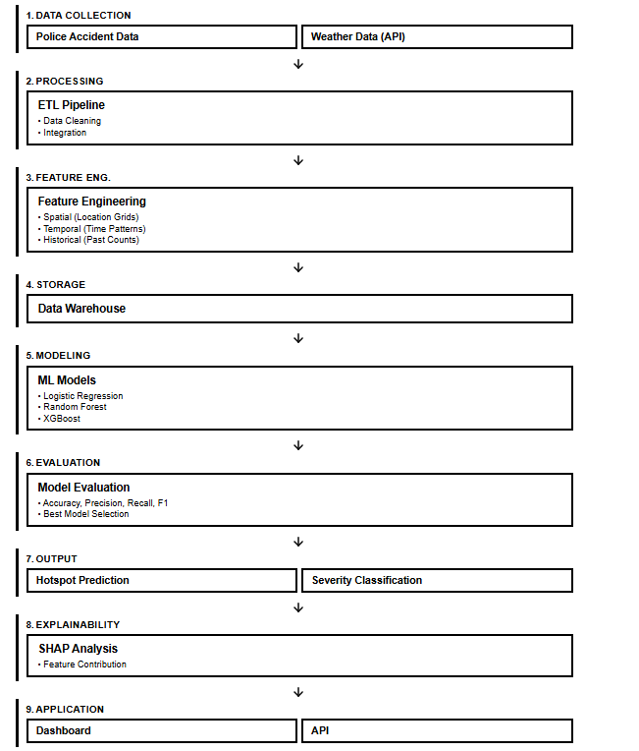
Figure 1 Overview of Methodology

3.2 Research Philosophy

When it comes to conducting certain research, it is very important to understand that it should be done according to a certain set of beliefs and assumption as such beliefs and assumption can affect the way of investigating a research problem, what kind of evidence considered valid and the way interpretation of results of the research. This process of understanding belief and assumption of the research is referring to research philosophy and its simply based on 3 parts, namely, ontology (nature of reality), epistemology (nature of knowledge) and axiology (things that can be considered as valuable during the process).

For this specific study, it is decided to use the pragmatism as the research philosophy as it mainly focusses on addressing real world problems through different kind of approaches that are suitable, when it comes to answering the research questions (Dudovskiy, 2025). Accordingly, as this study more focuses on developing a practical framework for traffic accident hotspot prediction instead of creating or a proving a universal theory, we can clearly say that it comes under the research philosophy pragmatism.

Moreover, the whole study is based on DSR methodology, which can be considered as another reason to choose pragmatism as the research philosophy. This is because studies done according to DSR approach needs to be evaluated on the factors such as study’s effectiveness and usefulness in solving a real world problem. However, it is found that knowledge contribution of a DSR research could be inspected using critical realism instead of pragmatism, it is stated that design and evaluation of the artefact itself needs be evaluated through the perspective of pragmatism as the value of such artefacts is indeed measured by its practical impact (Panakaduwa et al., 2025). Accordingly, it is clear that similar approach has been used when it comes to the implementation of proposed framework as its usefulness is indeed measured by its ability on providing useful insights to relevant authorities (lambda contribution) rather than claiming universal truths.

Also, studies that incorporate pragmatism as research philosophy are allowed to select and combine existence methodologies and technologies in order to solve research questions rather than following established set of traditional methodologies (“Mixing Qualitative and Quantitative Methods,” 2024). Accordingly, the same philosophy has been incorporated into this accident hotspot prediction framework as it combines existing methodologies like Poisson FDR distribution for hotspot identification, supervise machine learning approaches, and integration of SHAP XAI to improve the transparency and interpretability of machine learning models.

Not only that this study also faces some limitations such as data scarcity and usage of synthetic data and due to that research is only limited lambda contribution. So instead of providing ground truths about accident hotspots as the output of the research, it provides a technical framework that is rigorously tested and validated again Sri Lankan Colombo Municipal Area context.

According to the above explanations, it is clear that pragmatism is the most suited research philosophy for this study as it enables this study to follow DSR approach while allowing delivering of a useful artefact that solve real world problems instead of claiming universal theories or ground truths.

3.3 Research Approach
Research approach defines the ways we can use theories and evidences validated through existing studies in related to our own study. Accordingly, such approaches are divided into 3 categories, which are deductive, inductive and abductive. Accordingly, deductive approach refers to testing and validating existing theories via another research while studies done according to inductive approach comes with new theories based on the observations of the study itself. But when it comes to abductive approach, it uses both existing knowledge along with empirical evidence to come up with a solution to a practical problem (Saunders et al., 2023).
Accordingly, for this specific study, it is decided to use abductive approach as the final goal of this research is to output an artefact that addresses a real world problem. Accordingly, this study explores development of a framework that can predict accident hotspot and their severity in order to enable relevant authorities with early decision making ability instead of validating existing theories (deductive) or introducing universal truth via observations (inductive). As mentioned earlier, for this framework it is decided to combine established theories and technologies such as spatiotemporal feature engineering, XAI, statistical hotspot identification and during each stage of implementation of such features relevant design decision were made demonstrating abductive reasoning nature of the study.

Furthermore, previous studies also have shown that abductive reasoning would be a better approach for an artefact based research. For example, Panakaduwa et al. (2025) has mentioned that incorporating abductive reasoning in DSR approach research could be very helpful when it comes identification of research objectives and requirements. This is because it helps to conjoint exiting theories with practical problems.

According to the above explanations, it is clear that abductive research approach is the most suited research approach for this study as the final output of the research is about solving a real-world problem by using and combining existing knowledge and based on empirical evidences found on each subsequent stages.

3.4 Design Science Research Methodology
Based on previous chapters, now it is clear that this study aims to address a real world issue by providing a practical artefact. So, the Design Science Research (DSR) methodology is incorporated as it is the most suitable approach for such kind of framework. Moreover, above mentioned lambda and omega contribution explains this study’s contribution it doesn’t explain the in what order the research is conducted. Accordingly, in order to explain this how the research is conducted under DSR methodology it can be divided into following 4 phases.

3.4.1 Problem Identification
The problems addressed by this study and artefact were discussed deeply in the section 1.2 and were further explained with justification in section 2.4. According to those, Sri Lanka simply lacks a multi-source explainable spatiotemporal framework for traffic accident hotspot prediction and to classify severity of such hotspots. Furthermore, existing studies and empirical evidence such as Bhavan (2019) and (Dailymirror, 2026) shows how negative impacts from road traffic accidents affects towards both human lives and economy of a country despite tradition preventative measures, which justify the need for a framework similar to the proposed one. Also, existing studies and their limitations were also discussed in the section 2.3 and section 2.4 to further identify the research problem.

3.4.2 Solution Design
In this stage, we designed the system for the proposed framework based on the above identified problems and gaps. Accordingly, following design decisions were made when designing the solution.
- Multi Source data integration and storage via Mongo Atlas which also allows data reprocessing and traceability.
- Hexagonal Spatial Indexing (Uber’s H3) with resolution 8 instead of square grids to reduce corner adjacency when it comes to neighbor grid spatial analysis
- Statistical hotspot Identification via Poisson distribution paired with Benjamini-Hochberg FDR correct instead of percentile threshold
- Tree base ensemble models such as Random Forest and XGB were chosen as main models based on the previous studies and due to their suitability for tabular data

3.4.3 Development
This is the phase responsible for the implementation of above discussed solution design. Accordingly, this includes implementation of features such as synthetic data generation, ETL pipeline, both conventional and spatiotemporal feature engineering, hotspot identification and severity classification of each hotspot, machine learning model training and evaluation, XAI integration and dashboard development. Following DSR methodology and Lambda contribution, each of such components are supposed to well tested before integration, ensuring both technical feasibility and Rigorousness of the artefact.

3.4.4 Evaluation
The final stage of the research is about evaluating the developed framework.
The 2 ensembled machine learning models along with baseline line model will be evaluated via classification metrices such as accuracy, precision, recall and F1-Score in order to choose a candidate model for XAI integration. Additionally, synthetic data will be evaluated using Chi-square goodness-of-fit p-values to assess how closely the feature distributions match those of the source data.

However, it is very important to understand that such evaluations are focused more on technical feasibility and usefulness of the artefact across Colombo Municipal Area rather than claiming ground truth about road traffic accidents in Sri Lanka. This ensures the study is well aligned with lambda contribution.

3.5 Research Process
Following the DSR methodology mentioned above, this section will explain the actual research process briefly.

As the first step of the research process, fist we identified the research problem along with research gaps in existing studies and frameworks related to traffic accident hotspot prediction in first 2 chapters. Based on these reviews, we were able to identify that Sri Lanka lacks a multi-source spatiotemporal explainable machine learning framework for traffic accident hotspot prediction and severity classification. Once, a clear overview of the research is identified, we were able to finalize the research objective and questions.

With the defined research objective, then the data needed for the research collected as the next step of the whole process. Accordingly, weather data needed for the study was collected from the Visual Crossing Weather API, which covers the whole Colombo area. When it comes to historical road accident data, there were some limitations in data collection process. However, a very limited number of data were able to collect from Slave Island police station. But such, number of limited data is not enough for machine leaning model training and evaluation. To address this problem, it is decided to implement a structured synthetic data generation pipeline based on the knowledge about road traffic accident distribution obtained from empirical sources.

Following data collection, both data sources were then preprocessed via an ETL pipeline. Accordingly, processes like geocoding of locations, merging of weather data with historical traffic accident data, and feature engineering were carried out in this ETL stage. Also, feature engineering was performed to extract necessary variable needed for spatiotemporal analysis, which included steps like hexagonal indexing of locations and hotspot identification via Poisson FDR. As the output of this stage, a dataset that is suitable for model training was created and stored on Mongo Atlas.

Once the data is ready for model training, such data will be feed to supervised machine learning models, which are logistic regression, Random Forest and XGB. In here logistic regression act as a baseline comparison and other ensemble models are chosen based on the previous studies. Once trained and evaluated based on relevant metrices, that model becomes candidate model and SHAP will be integrated to it to improve the transparency and interpretability. Also, a dashboard and relevant APIs were developed to output results of the framework demonstrating both technical rigor and practical feasibility of the framework.

3.6 Requirement Gathering
As mentioned earlier, studies done according to DSR approach should address real world practical problems. However, it is very important to make sure that such requirements are not assumed by the researcher. So, a requirement gathering phase is very important to ensure those requirements of the study address real world problems. Accordingly, for this specific study, requirements were gathered though literature reviews, research gap analysis and practical limitations identified during the early stage of research. Also, as this study is more focused on lambda contribution it was decided to not to conduct any stakeholder interviews or questionnaires as such tasks require additional effort to get formal access to personnel of Sri Lankan Police or Road Development Authority. So, it was decided to focus on above mentioned approach for requirement gathering.

3.6.1 Requirements from Literature Review and Research Gaps Analysis
Accordingly following literatures which are related to road traffic accident hotspot prediction and severity classification were used to gather requirements.

Requirement | Justification | Source
The framework should combine multiple sources such as weather data along with historical accident data | This is because such multi source data integrations can improve model’s predictive performance and such integration are unexplored in Sri Lankan context. | - Santos et al. (2021)  - Ogungbire & Pulugurtha (2025
The framework should provide a grid based spatiotemporal analysis approach | This is because systems that can just predict location coordinates were unable to understand risk pattern variations across both time and location, which justifies the need for a Uber’s H3 hexagonal grids for spatiotemporal analysis | - Al-Omari et al. (2025)  - Ogungbire & Pulugurtha (2025
The system should use effective machine learning model for accident hotspot prediction and severity classification | This is because most of the existing studies found that ensemble models such as Random Forest and XGBoost works well compared to other alterantives | - Santos et al. (2021)  - J.M.C.T. Jayamanna & P. Kalansooriya (2024)
The framework should be able to predict traffic accident hotspot and classify severity of them | By doing this we can enable the framework to provide more information related to road traffic accident context and thereby enabling relevant parties with more completed decision-making approach | - Islam et al. (2022)  - J.M.C.T. Jayamanna & P. Kalansooriya (2024)
The framework should have improved interpretability and transparency via Explainable AI | This is becaues integrating XAI techniques such as SHAP can improve model’s transparency and interpretability. Some of the previous studies have identified this as a gap and recommended to integrate this for hotspot prediction frameworks | - Santos et al. (2021)  - Jayamanna & P. Kalansooriya (2024)
The framework should handle class imbalance of values such as “Fatal Severity” | Like mentioned, accident with fatal severity represents a small proportion of total sample in most of the dataset. Previous studies considered this a recurring issue and abled to address these by balancing the dataset | - Al-Omari et al. (2025)  - Ogungbire & Pulugurtha (2025
The framework should be designed in a way that it can address Sri Lankan Road traffic accident distribution | As most of the existing frameworks in other countries doesn’t transfer to Sri Lankan context due to differences in road accident distributions and contributing factors, this study aims to implement a framework that is more tailored to Sri Lankan context. | - Santos et al. (2021)  - J.M.C.T. Jayamanna & P. Kalansooriya (2024)
Table 2Requirement Gathered from Literature Review and Research Gaps Analysis

3.6.2 Requirements from Identified Practical Limitations
In addition to above mentioned requirements, it was also possible derive requirements based on the practical limitation identified during the early stages of the research.
- Lack of a Synthetic Data Generation Pipeline for Sri Lankan Context
  - Even though most of the studies related to this matter in Sri Lankan context have also acknowledged the data limitation issue, they have given less focus on addressing this issue through synthetic data generation (Jayamanna & Kalansooriya, 2024; Selvaratnam et al., 2025; Jayasinghe et al., 2025). So, a synthetic data generation pipeline was proposed as a requirement of this framework.
- Absence of Publicly Available Police Jurisdiction Shapefile
  - As a result of not having a published police jurisdiction shapefile for Colombo Municipal Area, it was decided to move with OSM based polygon approximation in order to define spatial boundaries in Colombo Municipal Area (Section 3.7.1.2.4).

3.7 Data Collection

3.7.1 Historical Police Accident Records
The main data source of road traffic accidents is historical road traffic accident data collected from Slave Island police station’s traffic department and those data lays the foundation for the development of traffic accident hotspot prediction and severity classification.

However, it is very important to understand that most of the well developed countries have centralized system to manage road traffic accident data. For example USA has a system called Fatality Analysis Reporting System (FARS) which is a centralized system for managing road traffic accident data (NHTSA, 2016). Similarly, Sweden also has a centralized system called Swedish Traffic Accident Data Acquisition (STRADA) which includes data on both road traffic collisions and injuries related those accident (Sweden Study Visit 2020, 2020).

But when it comes to Sri Lankan context, management of such data is still in transitional stage where most of such information are still maintained via physical records while a small portion are digitized. As a result of this most of this information are still not properly centralized. So, the data needed for this study had to be done by manually reviewing and extracting necessary anonymized data in corporation with Slave Island police station. Accordingly, it is very important to understand that collecting a large amount of data in this approach is both time consuming and resource intensive, making it impractical to complete within given time frame.

As a result of such limitation in data management related to road traffic accidents, only a limited number of data was able to be collected from Slave Island police station. Even though those collected data be able to give an idea on real world occurrence of road traffic accidents, such number of limited data is not enough for the training of proposed machine learning models. However, these collected data still provide the foundation for development of proposed machine learning framework.
When it comes to the content of this dataset, it includes all the essential spatial and temporal variables needed for the development of proposed machine learning framework. Accordingly, it includes spatial features such as location and temporal features such as data and time of the road accident occurrence. Other than those, features such as accident severity, vehicle involvement, cause of the accident, age group of drivers that contributed to the accident, cause of accident, collision type, number of fatalities and injuries, were also included and those variables are really important when it comes to identification factors contributed to the hotspot prediction and severity classification.

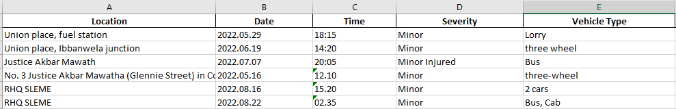
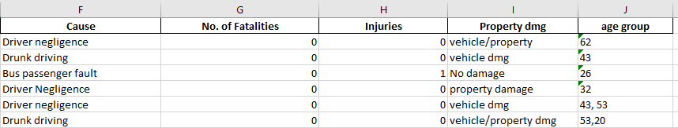
Figure 2 Sample Records from Slave Island Police Station

However, to address these limitations in data scarcity, a structured process tailored to Sri Lankan context has been used to generated synthetic data needed for feature extraction and model training.

Accordingly, for the synthetic data generation, empirical sources related to traffic accidents in Sri Lanka has been used to understand distribution of road traffic accidents and the features related to such accidents. Such sources are given below.

Anchor | Source | Fields Anchored
A1 | (“Department of Census and Statistics,” 2024) | Road accident distribution across Colombo Municipal Area
A2 | (“2025 Traffic Reports – SRI LANKA POLICE,” 2025) | National Severity Mix related to road traffic accidents (Fatal, Serious, Damage-Only, Minor)
A3 | (W. G. S. R. Thilakarathna et al., 2025) | Time of day and cause distributions for accident with fatal severity
A4 | (Jayasinghe et al., 2025) | Time of day and cause distributions for accident with non fatal severity
A5 | (Boeing, 2025) | Street name vocabularies for Colombo Municipal Area
Table 3 Empirical Sources
Once such knowledge is acquired, individual road traffic accident records in related to Colombo Municipal Area context has been generated using a structured synthetic data generation pipeline. By using this approach, we can make sure that such data are traceable to its sources.

Simply, the synthetic data generation process consists of 3 main principles:
- Source Based Generation:
  - Generation of certain important attributes based on empirical sources (Anchored Distribution) and feature structure obtained from collected Slave Island Police Station Data
- Explicit Assumption
  - For some attributes, modelling assumptions had to be made due to unavailability of data sources and empirical evidence.
- Conditional Generation:
  - Usage of probabilistic rules found on Sri Lanka studies related to traffic accidents to generate relationships between accident attributes.

Also, when it comes to coverage of synthetic data it was decided to generate for the year 2022-2023 based on the accident distribution data from the Department of Census and Statistics / DCS (“Department of Census and Statistics,” 2024). However, for this study, only 17 out of 22 Colombo Municipal Area has used for the synthetic data generation due to limitations in extracting polygons for those excluded area via OSMNX. Accordingly, 3688 road accident records were synthetically generated, covering 95% of the reported accident volume reported in the Department of Senses and Statistics Table.

Even though we generated above mentioned data records, they would fail to capture the relationships between attributes such as sevrity. This is because such base records were generated by independently sampling their marginal distribution. To address this issue, it is decided to introduce 3 conditional probabilistic rules for generated accident records and thereby to establish relationship between accident characteristics and severity. Accordingly, following empirical source were used to introduce such rules.

Conditional Rule | Condition | Severity Upshift Probability | Empirical Source
R1 | Night-time (18:00–05:59) and main road | +10% | (W. G. S. R. Thilakarathna et al., 2025)
R2 | Motorcycle or pedestrian involved | +15% | (“2025 Traffic Reports – SRI LANKA POLICE,” 2025)
R3 | Alcohol identified as cause | +20% | (W. G. S. R. Thilakarathna et al., 2025)

Also, in a situation where above-mentioned multiple conditions were satisfied, we add their relevant probability percentages to give a final output while also ensuring it capped at 50%. Accordingly, the relevant severity shift happens as follows.

Accordingly, for the synthetic data generation, a structured framework that incorporates empirical sources, rule-based probability adjustments, and explicit modelling assumption was used. This process provides a synthetic dataset with the traceability to its sources while also mimicking behaviors of road traffic accident in Sri Lanka upto some extent.

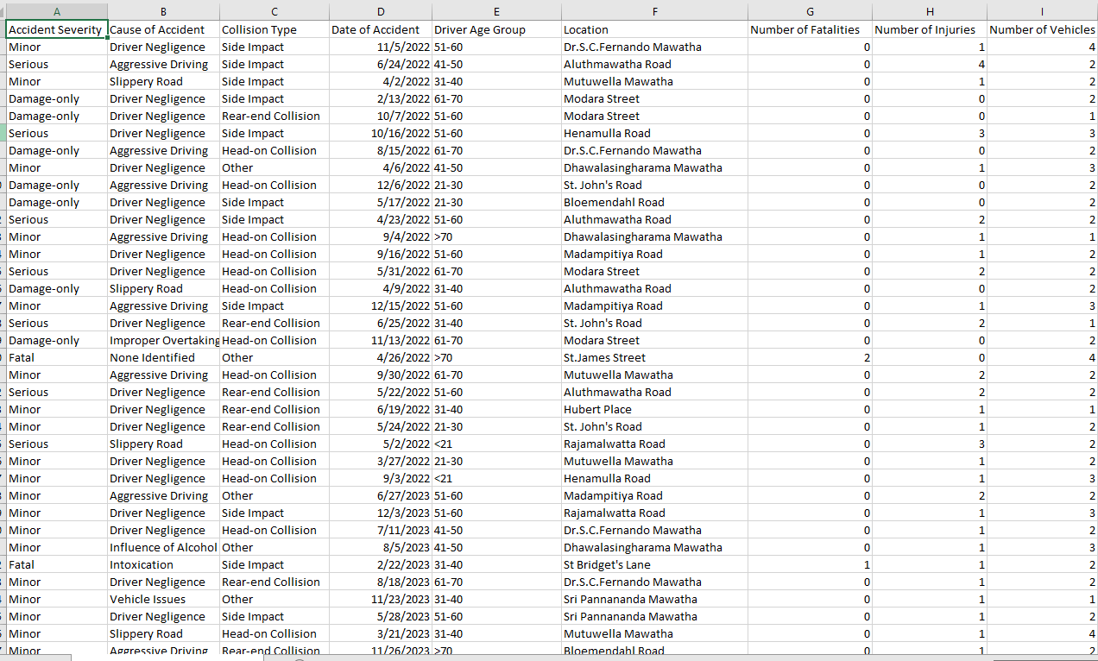

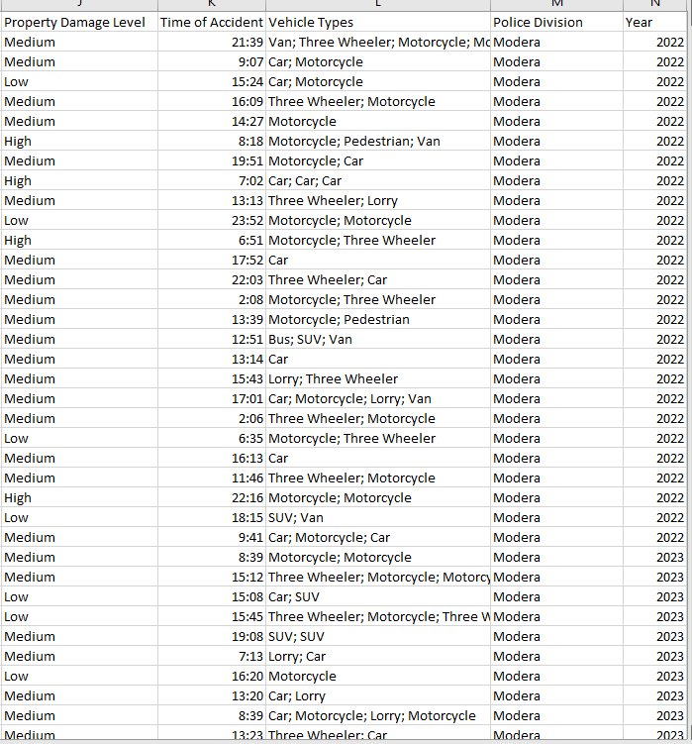
Figure 3 Synthetically Generated Data for Model Training

3.7.2 Weather Data
As mentioned in previous chapters, it is clear that integrating contextual data like weather data can improve model’s prediction performance. Accordingly, a weather dataset that covers the Colombo Area from the year 2022-2025 is obtained via Visual Crossing Weather API, thus developing a multi source machine learning framework for traffic accident hotspot prediction and severity classification in Sri Lanka (Weather Data & Weather API | Visual Crossing, n.d.). The integration of such data enables the model with more context and thereby improving its prediction performance. Also, by using this method, it is also possible to identify environmental factors that contribute for a certain road traffic accident. Furthermore, this dataset also aligns with the duration of road traffic accident dataset, ensuring it is associated with relevant historical traffic accident data record during the merging process.

Accordingly collected weather data includes features like weather condition (cloudy, rainy, partly cloudy ), precipitation, visibility, humidity, cloudcover, sunrise and sunset, enriching police accident dataset with environmental factors.Also, in addition to those mentioned features, feature engineering has performed to derive columns like weather_condition_label (cloudy, partly cloudy, heavy and light rain) based on precipitation value and visibility_level (good, moderate and poor) based on visibility values to provide more interpretable feature for machine learning models.

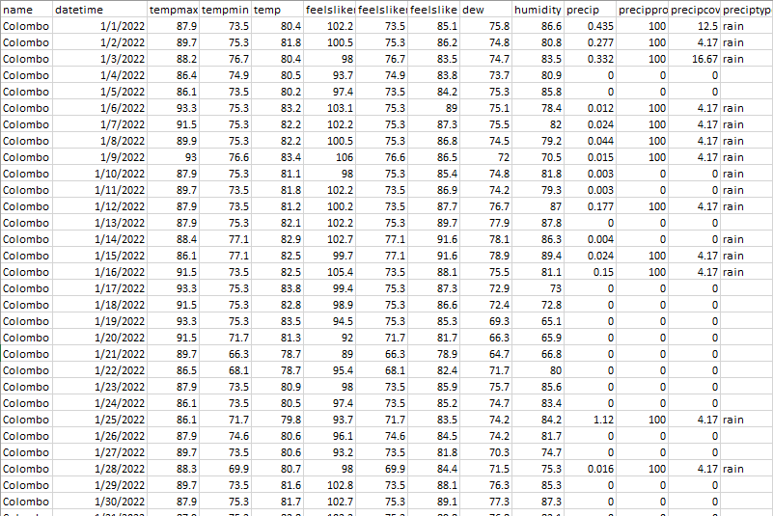
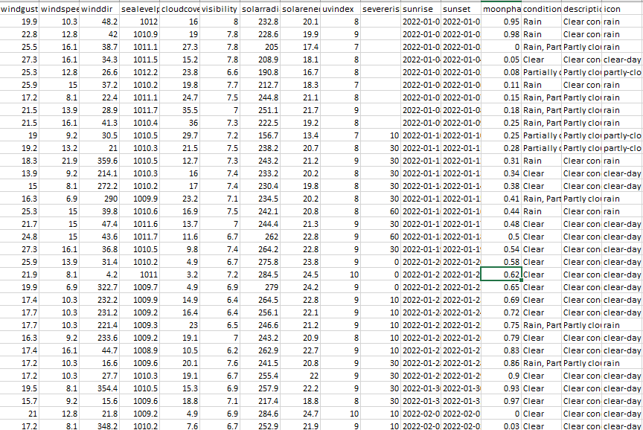

Figure 4 Weather Data Collected via Visual Crossing API

3.8 Hotspot Identification and Spatiotemporal Feature Engineering

3.8.1 Spatial Indexing via H3 (your H3 text and the resolution 8 choice)

When it comes to hotspot identification, standalone location coordinates of each accident that we geocoded via Google Map API in geocoding stage is not enough due to inability of such coordinates in understanding spatial context of road accident hotspots and not being aware about neighborhood context.. Because of this, it is decided to use Uber’s H3 hierarchical hexagonal indexing and transform this individual location coordinates of road accidents to spatial units (“H3: Uber’s Hexagonal Hierarchical Spatial Index,” 2026). The reason for choosing this specific Uber’s H3 indexing instead of square grid is because square grid introduces corner adjacency differences resulting in variations in distance between neighboring cells. However, such problems are not applicable to Uber’s H3 indexing as they use hexagonal shaped grids which enables all 6 adjacent cells to share an edge with a central H3 index while being approximately equidistant (“H3: Uber’s Hexagonal Hierarchical Spatial Index,” 2026). This is very important when it comes to understanding context of neighboring cells for spatial analysis. By doing this, we can make sure that each accident location coordinate gets assigned to a unique hexagon according to a predefined resolution along with analysis of neighborhood H3 cells for accident hotspot identification.

When it comes to implementation each longitude and latitude related to a road traffic accident is mapped to cell via using the function give below,
c_{i​} = H3(lat_{i}​,lng_{i}​,r)

Accordingly, in here C_{i} represent the cell identifier for a given accident “i” and “r” represent the resolution at which the each cells are represented.

Moreover, when it comes to H3 resolution selection (r), initially we selected 2 candidate H3 resolutions which are resolution 8 and 9. However, after comparing both, it is decided to select resolution 8 as primary resolution, where each H3 cell covers and approximate area of 0.737km² (“Tables of Cell Statistics Across Resolutions | H3,” n.d.). This is because choosing higher resolution for a cell can cause problems such as spatial sparsity due to the limited number of data causing most of the cells to have a zero or limited number of accidents, enabling such cells to act almost as individual location coordinates. Therefore, resolution 8 has chosen which acts a balance of both ends making it much more suitable for spatial analysis of a area like Colombo Municipal Area.

3.8.1 Hotspot Identification Criteria (the Poisson and Benjamini–Hochberg part)
So in order to predict traffic accident hotspots and thereby to satisfy the relevant objectives, first we need to setup hotspot labels itself for the relevant data points. Accordingly, by using the same H3 indexing approach that we discussed above, each accident is inserted to a H3 cell based on their geo coordinates along with total accident counter per each cell.

Accordingly, under null hypothesis of Complete Spatial Randomness (CSR), we expect a certain number of accidents to be included in each cell based on the average accident rate that we calculated using the total number of accidents in the collected dataset. However, if a certain H3 cell has significant higher number of accident count than this expected average, then that H3 cell is labelled as a hotspot. The reason for using this method instead of arbitrary percentile-based threshold because such constant thresholds are unable to provide any statistics for the chosen percentile.

When it comes to calculating expected average accident count for each cell based on CSR, we use Poisson distribution with rate parameter lambda (λ) being equal to the mean accident count of all H3 cells:

$$λ=\frac{1}{\left|C\right|}\sum_{c∈C}{n_{c}}$$

Accordingly, in here,
  - C represent H3 Cells with at least one Accident,
    - Therefore |C| = Total Number of Cells with at least one Road Accident
  - n_{c} = Number of Accident inside cell “c” ("c” is a selected individual cell in here)

Once (λ) is calculated, a “P-Value” for each H3 cell is calculated to get the probability of having same accident count or greater (as much as n_{c} in the above equation) than (λ) via using the below null model:

$$p_{c}=P\left(X≥n_{c} ∣ X∼\text{Poisson}\left(λ\right)\right)=1-F_{\text{Poisson}}\left(n_{c}-1;λ\right)$$

Accordingly, in here,
  - P_{c} = Probability of having same accident count or greater than the observed accident count in n_{c} for cell “c”. For this we have to assume that accidents are randomly spread across the study area.
  - X = Random variable that is used to represent expected accident count for a cell “c” according to Poisson distribution.
  - $\text{Poisson}\left(λ\right)$ = Poisson distribution with the above calculated (λ) as expected average accident count per cell
  - $F_{\text{Poisson}}$ = Cumulative Distribution function of the Poisson which is used to calculate the probability of getting a value less than or equal to a given accident count

Accordingly, if we get a small P-Value (P_{c}) for a given cell, that means the accident count that we have is highly unlikely to happen according to spatial randomness. This means that specific H3 cell could be a potential hotspot.

However, during the identification of above mentioned hotspots, it is clear that we had to perform statistical test for each and every cell. This kind of multiple hypothesis tests can lead to increased number of false positive rate. As a solution for this problem Benjamini-Hochberg False Discovery Rate (FDR) correction is used to adjust the above calculated P-Values to make the hotspot labelling process stricter (Benjamini & Hochberg, 1995).

Accordingly, when it comes to applying Benjamini-Hochberg FDR, calculated P-Value were ranked in ascending order and each of them were compared against the threshold value calculated using the below equation.
$$p_{\left(k\right)}≤\frac{k}{m}α$$

Accordingly, in here,
  - k = Rank of the P-Value (after reordering in ascending order)
  - m = Total number of H3 cells tested.
  - $α$ = Significance level (0.05 in this case)

Once calculated, H3 cells with adjusted P-Value below the 0.05 were decided to label as accident prone hotspots.

3.8.3 Causal Rolling Spatiotemporal Features

The hotspot labels that we generated in the above process via the road accident records covers the whole timeline of the dataset. However, providing that kind of whole history for given H3 cell as an input to a machine learning model can cause severe problems like data leakage (IBM, 2024). For example, model is not supposed to know the hotspot status for a given H3 cell for the data 20th of June 2026, when it’s supposed to predict the hotspot status for that date.

Accordingly, as a solution to such kind of problems, spatiotemporal temporal features were engineered using causal (temporarily ordered) formula. By doing this we can make sure that only prior accident records for a given accident event are provided to the relevant machine learning model and thereby preventing leakage of outcome of a certain prediction as a feature.

When it comes to implementation of such features, it is decided to implement 2 kinds of spatiotemporal features for both same cell and its neighbor cells with the trailing time windows of 30,90 and 180 days respectively.

- Rolling Spatiotemporal Features for Same H3 Cell

$${\text{same}\text{_}\text{cell}\text{_}\text{count}}_{i}\left(w\right)=\left|\{j:c_{j}=c_{i}, t_{i}-w≤t_{j}<t_{i}\}\right|$$

In here,
  - w = Time Windows (30,90 and 180 days)
  - C_{i} = H3 Cell that containing a given accident “i”
  - C_{j} = H3 Cell that containing a previous accident “j” for a given accident “i”
  - T_{i} = Time of accident “i”
  - T_{j} = Time of accident “j”

Accordingly, this gets the number of previous accidents for same H3 cell for a given time window.
- Rolling Spatiotemporal Features for neighbor H3 Cell (Spatial Lag)

$${\text{neighbor}\text{_}\text{count}}_{i}\left(w\right)=\{j:c_{j}∈N\left(c_{i}\right), t_{i}-w≤t_{j}<t_{i}\}$$

In here the only difference is
  - $N\left(c_{i}\right)$ which is used to depict first order neighboring H3 cells for a given H3 cell. In here the given H3 cell itself is excluded.

Accordingly, this gets the number of previous accidents for neighboring H3 cell for a given time window.

In both above occasions, $t_{j}<t_{i}$ make sures that only prior accidents for a given accident event are included for the relevant feature engineering, while preventing data leakage by ignoring the given accident itself and its future events.

The outcome of this stage is 6 causal spatiotemporal features for each accident that helps machine learning models to learn patterns related to road traffic accident in both same H3 cell and its neighboring cells.

3.9 Software Development Methodology
As this is a DSR research that is focused on outputting software artefact, software development methodology needs to be followed to make sure that relevant features are developed and integrated properly during the development of the artefact. However, such methodologies can be categorized into several approaches like plan driven approaches and iterative approaches and most suitable one needs to be chosen.

Accordingly, it was decided not to use plan drive approaches such as waterfall as we could not finalize some of the design decisions before the actual development. For example, when it comes to hotspot identification process, several approaches such as classifying hotspots based on arbitrary percentile threshold, Getis-Ord and Poisson Distribution along with Benjamini-Hochberg False Discovery Rate (FDR) were considered, before finalizing Poisson Distribution along with Benjamini-Hochberg False Discovery Rate (FDR). Similarly, choosing the correct H3 resolution also followed a trial-and-error approach before finalizing “H3 resolution 8” as final resolution. So it is clear that, this study required a iterative approach that allows repeated implementation, testing and refinements rather than fixed path.

As per the above mentioned requirements, it was decided to choose a Agile based iterative and incremental approach for the software development methodology. This is because this approach allows each phase of the artefact development which includes process such as Mondo Atlas data lake creation, geocoding, weather data integration, conventional and spatiotemporal feature engineering, model training and evaluation, XAI integration and dashboard development to be build, test and refine. Also incorporating this method enabled to change technical and design decision when there were limitations on established decisions (Lutwama et al., 2024).

Also, even though we adopted an Agile based iterative approach, it is very important to understand that fully structured scrum was not used as the study was carried out by a single student. So, it was decided to adopt only iterative principle of Agile methodology for this study.

3.10 Artefact Evaluation Strategy
As mentioned earlier, DSR artefact should be able to address practical problem. So, under DSR concept it is very important to evaluate the designed framework to show that it can address the research problems that it’s supposed to address and can fulfill the design requirements. Accordingly, the relevant evaluations were done according to the ex post method which comes under FEDS framework. This means the relevant evaluation were done after completing the implementation of relevant components (Venable et al., 2016).
Also, as the study were more focused on lambda contribution than claiming ground truth about road traffic accidents, it was decided to carry out relevant evaluation under controlled environment, following a benchmark style instead of using live environment or real users.

Accordingly, validation strategy of this framework can be divided into 2 parts as synthetic data validation and framework validation. However, as the framework itself is considered as a lambda contribution under DSR approach, it is very important to understand that none of these layers claim ground truth about road traffic accidents. As mentioned above both of these layers are only supposed to rigorously test the framework in technical manner

3.9.1 Synthetic data Validation
This part of the evaluation was used to make sure that the synthetic data we generated form empirical evidence shows a defensible representation of road traffic accidents in Sri Lankan context. Accordingly, such evaluations were done according to 2 following approaches.

3.9.1.1 Marginal Fidelity via Chi Square Goodness of Fit
This evaluation strategy involves comparing anchor distribution that we obtained from empirical sources and used for synthetic data generation with synthetic data distribution itself using Chi Square Goodness of Fit approach. Accordingly, such comparison involves severity distribution against “2025 Traffic Reports – SRI LANKA POLICE,” (2025), fatal accident time band and causal distribution against W. G. S. R. Thilakarathna et al. (2025), non fatal accident time band and causal distribution against Jayasinghe et al. (2025). Also, for the statistical significance, it was decided to go with $α = 0.05$
However, it is very important to understand that severity distribution of whole dataset may get deviate of anchored source distribution because of the conditional rules (R1 to R3) that we used to increase probability of severe outcomes based on specific conditions such as motorcycle or pedestrian involvement, alcohol as cause, nigh time and such variations are supposed to taken into consideration when interpreting results rather than just considering them as failures.

3.9.1.2 Joint Dependency Validation
As mentioned earlier, synthetic data generation was done using marginal sampling, which resulted in generation of variables without any relationships. So, to address this limitation, we decided to introduce conditional rules that add relationships to certain variables. However, it is very important to make sure that such rules give us the expected relationships among relevant variables. So, the cross tabulations of severity against those selected variables were conducted using below approach.

- Difference between severity distribution according to night and day (Tests R1)
- Changes to severity distribution based on pedestrian and motorcycle involvements (Tests R2)
- Difference between severity distribution according to alcohol and non alcohol as a cause of accident (Tests R3)

Accordingly, as the output of this evaluation strategy it is expected to see improvements to severity based on such relationships.

3.9.2 Framework Validation
The other part of the evaluation strategy is the framework validation itself. When it comes to technical performance, it was decided to use standard classification metrices on hotspot and severity classification process. Accordingly, the synthetic dataset will spitted using a temporal split where data from January, 2022 to September, 2023 belongs to train split and data from September, 2023 to December, 2023 belong to test split. By doing this we can ensure that relevant classifiers would genuinely learn patterns instead of memorizing. Once trained evaluation would be done via following standard metrices, which were chosen based on previous established studies such as Yumak et al. (2025)

- Accuracy – Overall classification correctness across both hotspot and severity classifiers
- Precision, Recall and F1-Score – To assess model’s ability in categorizing severity classes of the accidents. This is very important due to class imbalance caused by fatal severity as it represents only 12% of the dataset.
- Confusion Matrix – To get an idea of overall misclassification made by relevant machine learning models.
- ROC-AUC – Specifically used for binary classification of accidents hotspots (H3 hexagons)
- Macro-averaged F1 – This is for severity classifier as it contains multiple classes. By doing this, we can make sure that equal importance given to every severity classes which included lesser dominant ones like fata severity.

Also, it is very important to understand that this evaluation is only there to understand how well above classifiers perform on unseen data and thereby to choose a candidate model from Logistic regression, Random Forest and XGBoost and not to validate that such patterns can be generalized into real world accident records.

3.9.3 Threats to Evaluation Validity
Even though we established a well defined evaluation strategy, some limitations were identified as follows,
- Dataset split being dependent on Synthetic Data
  - As data needed for both training and test phases were split from generated synthetic data, it is very important to understand that those does not reflect real world performance.

3.11 Research Validity and Reliability
When it comes to DSR methodology, it is very important to establish both research validity and reliability. Accordingly, research validity means whether the relevant study measures what it supposed to measure and draw suited conclusions based on its output while research reliability ensures that the same methodology followed in certain research can be repeated to get either consistent result or can apply for a different study (Storey et al., 2024).

3.10.1 Research Validity
When it comes to validity of the research, it is mainly established by anchored sources, above mentioned lambda contribution scoping. Accordingly, validation of this research was done according to 4 types of validation techniques.

3.10.1.1 Construct Validity
Accordingly, construct validity helps us to ensure whether the variables and measurement that we used for this study truly represents concepts that they are supposed to measure. Such validations were established by ensuring relevant variables are truly aligned with empirical sources that we found. Accordingly, it is ensured in the below way
- Structure of variables like “Severity Class” was directly derived from the classification system used Sri Lankan Police (“2025 Traffic Reports – SRI LANKA POLICE,” 2025). This ensures that the structure of such variables directly matches with the structure of national level data.
- Also distribution of road accidents across Colombo Municipal Area were directly derived from data obtained from DCS, ensuring such distributions are correlated with real world distribution (“Department of Census and Statistics,” 2024).
- Similarly temporal patterns were also derived from previous empirical studies that studied the distribution of road accidents across time of the day such as W. G. S. R. Thilakarathna et al. (2025) and Jayasinghe et al. (2025)

However, due to the data limitation, it wasn’t possible to derive every variable from empirical sources. As a result, such variables were derived via explicit modelling while ensuring transparency via reporting.

3.10.1.2 Internal Validity
Internal validity makes sure that the observed results of the artefact are mainly due to the designed framework rather than unintended factors. Accordingly, few threats for internal validity were identified and addressed as follows.
- Circular Validation
  - Another problem was learning of circular finding by the models. This is because the designed framework is mainly trained and tested via the same synthetic data. However, by ensuring this framework as a lambda contribution the impact of these kinds of issues was minimized.
- Mistaking Conditional Rules as Patterns
  - Effects from conditional rules shouldn’t reflect real world distributions. They were only supposed to create relationships among selected variables. This is addressed by being transparent about them via documentation of such rules against the empirical sources.

3.10.1.3 External Validity
External validity is there to check whether the finding of a study can be generalized beyond the context of the study itself. However, due to data limitation in Sri Lanka, such generalization was limited. Accordingly, external validity is limited in following ways,
- Temporal Scope
  - Synthetic data generation was limited to the period of 2022 and 2023 due to limitations in empirical sources to anchor such distributions. So, such distributions may not be valid for earlier periods.
- Limited to Sri Lankan (Colomo Municipal Area) Context
  - Even though the designed methodology can be transferred to other context beyond Sri Lankan Colombo Municipal Area context, cross country generalizations are not claimed. This is because anchored sources use to derive synthetic data were explicitly related to Sri Lankan context.

3.10.1.4 Conclusion Validity
Conclusion validity concerns whether the statistical and analytical conclusions which were derived from results of the study can be justified and issues related to this matter are addressed as follows.
- Explicit Reporting of Statistical Significance
  - For this Chi Square Goodness of Fit (section 3.9.1.1) was used to assess whether the synthetic data has a similar distribution in relation to anchored sources.
- Reporting of Small Real Sample Caveats
  - Even though we collected real accident records from Slave Island police station, that limited number of records limits the generalizability of the study. So, the results were only used as a supporting evidence that the framework works use within the relevant context, without claiming any ground truths for larger areas . Also, such limitation and are openly admitted though the reporting
- Reporting of Effect Sizes of Conditional Rules
  - Also, above mentioned joint dependency rule validation process was designed to output both absolute and relative changes in severity, enabling us to judge practical importance along with statistical significance.

3.10.2 Research Reliability
Reliability of this study is mainly ensured via reproducibility, reliability and being transparency about limitations. Accordingly, following steps were taken into consideration.
- Reproducibility
  - When it comes ensuring reproducibility of synthetic data techniques like random seed were used to ensure that we get same set of records through the usage of same anchored distribution. The same approach was also used when it comes to splitting of dataset for model training and evaluation.
- Traceability
  - Most of the sources that we used to understand accident distribution and designing of the framework can be traced back to their sources. For example, anchors that we used to generate certain synthetic variables were linked to their empirical sources in section 3.7.1.2.2. Also, during the event of empirical sources were not available for certain variables, it was decided to generate them via explicit modelling assumption and such decisions were openly acknowledged.
- Transparency of Limitations
  - Limitations of the research such as data limitations, difference between empirical sources, geocoding limitations, limitations in spatiotemporal analysis and etc. were also openly admitted and documented to ensure transparency and reliability of the research, improving overall transparency of the research.

3.12 Ethical Considerations
Even though, this study didn’t involve any human interactions or responses via either questionnaires or interviews, this study still requires the ethical consideration due to factors like collection of real accident records form Slave Island police station and usage of third-party data or empirical sources. Accordingly, such ethical considerations were handled as follows.

Handling of Real Accident Records
As mentioned earlier, real road accident records that happened in the year 2022 within Slave Island police jurisdiction were obtained from the relevant police station. Even though this process didn’t involve any human participant such records still included sensitive information of victims of road accidents. Accordingly, such data were only collected after getting the consent of Slave Island Police Station Traffic OIC under the condition of anonymizing such data. Therefore, it was decided to not to collect any Personal Identifiable Information related to road traffic accidents such as names, addresses or vehicle registration numbers, collecting only needed information such as location, date and time, cause, age group, cause of accident, vehicle type, number of injuries and casualties for this framework.

Use of Published Data Sources
The empirical sources such as Sri Lankan police report summary, DCS accident distribution tables, and other literature, that were used to derive accident distributions to generate synthetic data were properly cited. Moreover, such sources were only used to derive distribution that were intended by the authors. For example, W. G. S. R. Thilakarathna et al. (2025) only studied postmortems related to fatal only accidents. Therefore, such distributions were only used to generate accident with fatal severity. Also, when there were inconsistencies between such sources and generated synthetic data, they were openly admitted and reported through documentation, ensuring transparency.

Ethical Consideration of Synthetic Data
As mentioned earlier, synthetic data was generated from the accident distributions obtained from above mentioned empirical sources and such sources never included personal information. Therefore, it is clear that such kind of personal information was never used in the synthetic data generation process, ensuring no privacy concern on such data. This also allows publication of this dataset in platforms such as Kaggle without any privacy concerns.

Responsible Communication of Results
As this study outputs a framework that can predict accident hotspot and their severity, there is a possibility of misinterpreting such outputs as ground truth related to Colombo traffic accidents. However, such kind of misinterpretation and their impacts were addressed by explicitly scoping the research as a lambda contribution and framing the outputs as demonstration of the technical capabilities of the artefact rather than information for creating policies.

3.13 Chapter Summary
In this chapter, we explored the methodology adapted to design and develop the proposed accident hotspot prediction and severity classification artefact. Accordingly, it was decided to incorporate Design Science Research (DSR) approach for this study because of the proposed practical artefact. Moreover, the study was more focused on lambda contribution rather than claiming ground truth about Colombo road traffic accidents.

When it comes to the research philosophy, it was decided to select pragmatism approach, as the study focuses mainly on developing an artefact that solves a real world problem. Also, as this study combines several existing technologies to solve a problem, an abductive approach was chosen as the main research approach. In addition to these, an Agile based iterative approach was incorporated into the software development process.

Furthermore, this chapter explains how the requirements of the artefact were identified and gathered via literature review, gap analysis and practical limitations that were identified during the early stage of the research. This chapter also explores data collection process of the research. Accordingly, due to data limitations and lack of centralized data management to gather historical traffic accident related data, it was decided to synthetically generate such data based on the distribution obtained from empirical sources and modelling assumptions. Additionally, VisualCrossing API was used to collected weather related data for Colombo District.

Once the data generation is done, then we preprocess such data through an ETL pipeline. Accordingly, during this step, such data will go through steps such as geocoding of locations, merging of weather data and spatiotemporal feature engineering which includes processes such as H3 indexing and hotspot identification via Benjamini-Hochberg FDR correction. Then we used the processed data to train relevant supervised learning models. Accordingly, based on previous studies, it was decided to train and evaluate 3 models, logistic regression as a baseline comparison, Random Forest and XGB as main ensemble models. Among them, a candidate model was chosen based on performance and SHAP will be integrated to improve model interpretability. Once that done, the insights that we found will be visualized via dashboard.
Other than the overall process, this chapter also explores evaluation strategies for both synthetic data validation and framework validation. Accordingly, for synthetic data validation, approaches such as Chi-Square goodness of fit and joint dependency validation have been incorporated. Additionally, by using classification performance and SHAP – based explainability evaluation, the framework itself will be evaluated. Moreover, the chapter also explored validity and reliability of research through construct, internal, external and conclusion validity along with reproducibility and traceability to ensure reliability.

In conclusion, this chapter helps us to scope this research as a technical demonstration of the proposed framework rather than claiming ground truth about road traffic accidents in Colombo.

Chapter 4: Proposed Solution

4.1 Introduction
In earlier chapter, we discussed about the methodology that we are using to design and develop the accident hotspot prediction and severity classification framework along with other aspects of the study like research approach, data sources, modelling strategy and evaluation protocol. Accordingly, this chapter explores how such methodological decisions can be used to implement the prototype version of the proposed artefact.

This chapter starts by establishing functional and non-functional requirements which were obtained from objectives, identified research gaps and practical constraints. Once requirements were defined, the chapter then explores the proposed solution along with system architecture through main design components such as use cases, prediction flow and key dashboard interfaces. Furthermore, the chapter also explores chosen machine learning models, dataset and data preparation process, technology stack and implementation environment.

The outcome of this chapter would be an implemented prototype version multi source spatiotemporal explainable artefact for traffic accident hotspot predication and severity classification. Also, the outputs of the artefacts will be visualized through dashboard developed using REST APIs.

4.2 Requirement Analysis
As mentioned in chapter 3 section 3.6 the requirements of this study were gathered through the exploration of literature, research gap and practical constraint identified during the early stages of the study. Gathered requirements were then divided into function and non-functional requirement as given below.

4.2.1. Functional Requirements

Requirement ID | Requirement
FR 1 | The framework should combine multiple sources such as weather data with historical accident data into a unified dataset
FR 2 | The framework should generate synthetic data for historical accidents records based on the distribution obtained by local empirical studies to address the historical accident data limitation issue
FR 3 | The framework should facilitate spatiotemporal analysis through techniques Uber’s H3 hexagonal approach with resolution 8 and rolling historical windows using information available before the month that is supposed to predict.
FR 4 | The framework should be able to identify hotspots using statistical methods such as Poisson distribution paired with Benjamini-Hochberg FDR
FR 5 | The system should train and evaluate machine learning models such as logistic regression, Random Forest and XGB to identify suitable ml model for accident hotspot prediction and severity classification tasks.
FR 6 | The system should generate feature contribution explanation for a certain hotspot and severity prediction though SHAP
FR 7 | The framework should visualize the predicted hotspots and severity of them through REST APIs and an interactive dashboard
Table 4 Functional Requirements

4.2.2 Non-Functional Requirements

Requirement ID | Requirement | Description
NFR 1 | Interpretability | The framework should use SHAP to provide interpretable predictions highlighting features contributed to a certain prediction
NFR 2 | Leakage Safety | The framework should only use appropriate split from training split for tasks like preprocessing, threshold selection and model selection while restricting the temporal test set to be unseen
NFR 3 | Contextual Relevance | Generated synthetic data should represent Sri Lankan specific accident distribution, features and labels
NR 4 | Class Imbalance Handling | The framework should handle class imbalance of values such as “Fatal Severity”
NR 5 | Reproducibility | The framework should ensure reproducibility of components such as dataset, feature panels and machine learning models through techniques like fixed Random Seed and deterministic processing
NR 6 | Traceability | The rules that used to generate synthetic data should be traceable to their original Sri Lankan empirical sources.
Table 5 Non-Functional Requirements

4.3 Proposed Solution
As mentioned in earlier sections, the artefact developed in this study is an explainable, multi-source spatiotemporal framework that can predict traffic accident hotspots and classify severity of them. Also, due to certain limitations, this version of prototype is only designed to cover the Colombo Municipal Area. Accordingly, the main purpose of this study is to output a framework that can predict both accident prone locations/hotspots and severity of such hotspots along with explanations about why such predictions were made.

Accordingly, the artefact was proposed to address gaps in existing studies, which were already discussed in earlier chapters. For example, when it comes to Sri Lankan context most of the existing studies have given very lesser focus to integrating contextual data such as weather data. Even in the study by Jayamanna and Kalansooriya (2024), only historical police accident records were used for accident hotspot prediction and severity classification tasks. In addition, to that this research also explores how accident hotspots and severity can be varied across both time and space through spatiotemporal analysis, which was facilitated using techniques like Uber’s H3 indexing and temporal feature engineering. Moreover, the proposed artefact also addresses transparency limitation of machine learning model though XAI techniques like SHAP, which is also underexplored when it comes to Sri Lankan context. In addition to these, results of the artefact developed in other countries and datasets that they used to train relevant machine learning models may not transfer well to Sri Lankan context due to different weather and traffic patterns, structural difference of datasets and etc. However, the proposed artefact addresses this issue by considering Sri Lankan specific data and distributions, which were obtained from Sri Lankan empirical sources instead of directly applying frameworks developed for foreign countries to Sri Lankan context.

Accordingly, the framework consists of several core functionalities. First part is synthetic data generation based on distributions obtained from Sri Lankan empirical literatures and defined conditional rules. Next functionality of the framework is multi source data integration stage where we clean, preprocess and combine accident records with weather data. The framework then performs spatiotemporal analysis through techniques like Uber’s H3 indexing to identify traffic hotspots based on both location and time. Once these done, machine learning component of the framework will train and evaluate logistic regression, Random Forest and XGBoost using the data that were prepare though ETL pipeline. Once evaluated, the SHAP will be applied to candidate models for hotspot prediction and severity classification to improve the interpretability by outputting features that contributed to a certain prediction. As the final functionality of this framework a prototype dashboard will be developed to demonstrate how the predictions made by relevant machine learning models can be visualized.

4.4 System Architecture
When it comes to the architecture of the proposed artefact, it follows 5 layer architecture that unify independent processes such as data sources, data processing, and storage, machine learning, explainability and demonstration of the output though APIs and a dashboard. Accordingly, those 5 layers are Data Sources, ETL and Feature Engineering, Data Storage, Modelling and explainability and delivery.

- Data Source Layer
  - This layer carries data collection, synthetic data generation and merging processes. It included processes like collection of real data though Slave Island police station and Visual Crossing weather API, synthetic data generation using statistical distributions obtained from Sri Lankan empirical literatures and defined condition rules and merging of these data for further preprocessing.
- ETL and Feature Engineering Layer
  - This is the layer responsible for preparing above collected data for model training though data preprocessing and feature engineering techniques. Accordingly, it includes processes such as data cleaning, geocoding of location data via Google Maps API, spatiotemporal feature engineering that involves conversion of location data into H3 indexes, identification of hotspots and creation of final training panel (cell/moth panel) by combining accident and weather data based on location (H3 cell) and time (month) information
- Data Storage Layer
  - This layer is responsible for the storage all kind of data. This includes raw data, processed data and even output of the framework such as predicitons and SHAP explanations. Accordingly, Mongo Atlas was selected as the main data storage, allowing other relevant layers to access such data according to the given needs.
- Modelling and Explainability Layer
  - In this layer, the above processed data will be used to train and evaluate machine learning models such as logistic regression, Random Forest, XGBoost and SHAP will be integrated to hotspot classifier candidate model and severity classifier candidate model.
- Delivery Layer
  - Outputs of the framework which included both hotspot and severity along with SHAP explanations will be visualized to the end user though this layer. Accordingly, such visualizations will be provided through developed REST APIs and a prototype Dashboard.

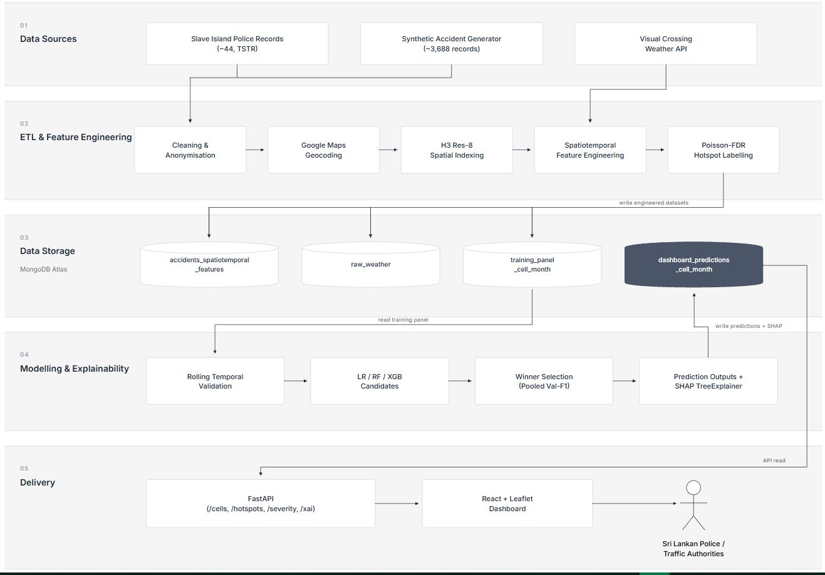
Figure 5 System Architecture

4.5 System Design

4.5.1 Use Case Diagram

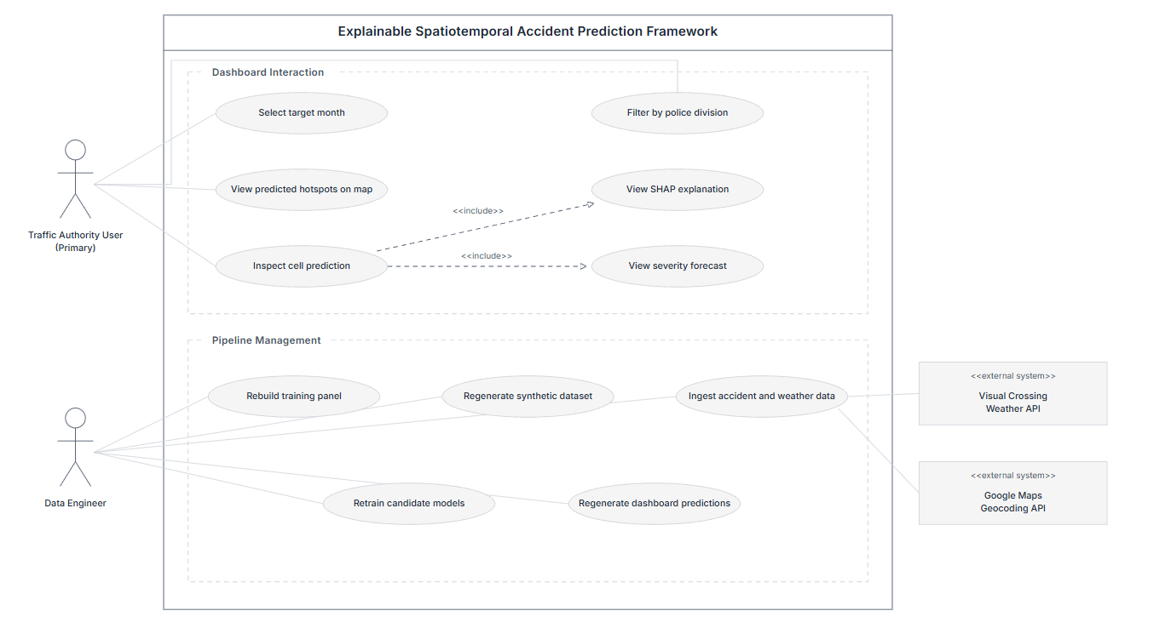
Figure 6 Use Case Diagram

4.5.2 Class / Data Scheme Diagram

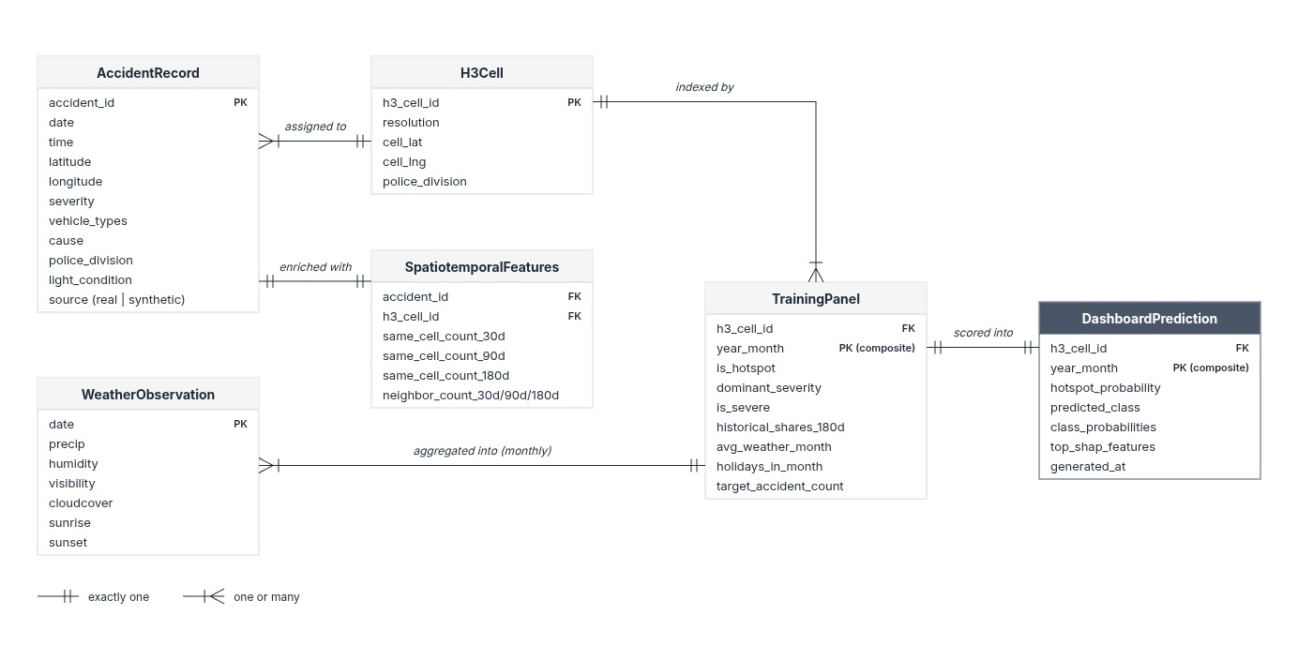
Figure 7 Class Diagram

4.5.3 Activity Flow Diagram

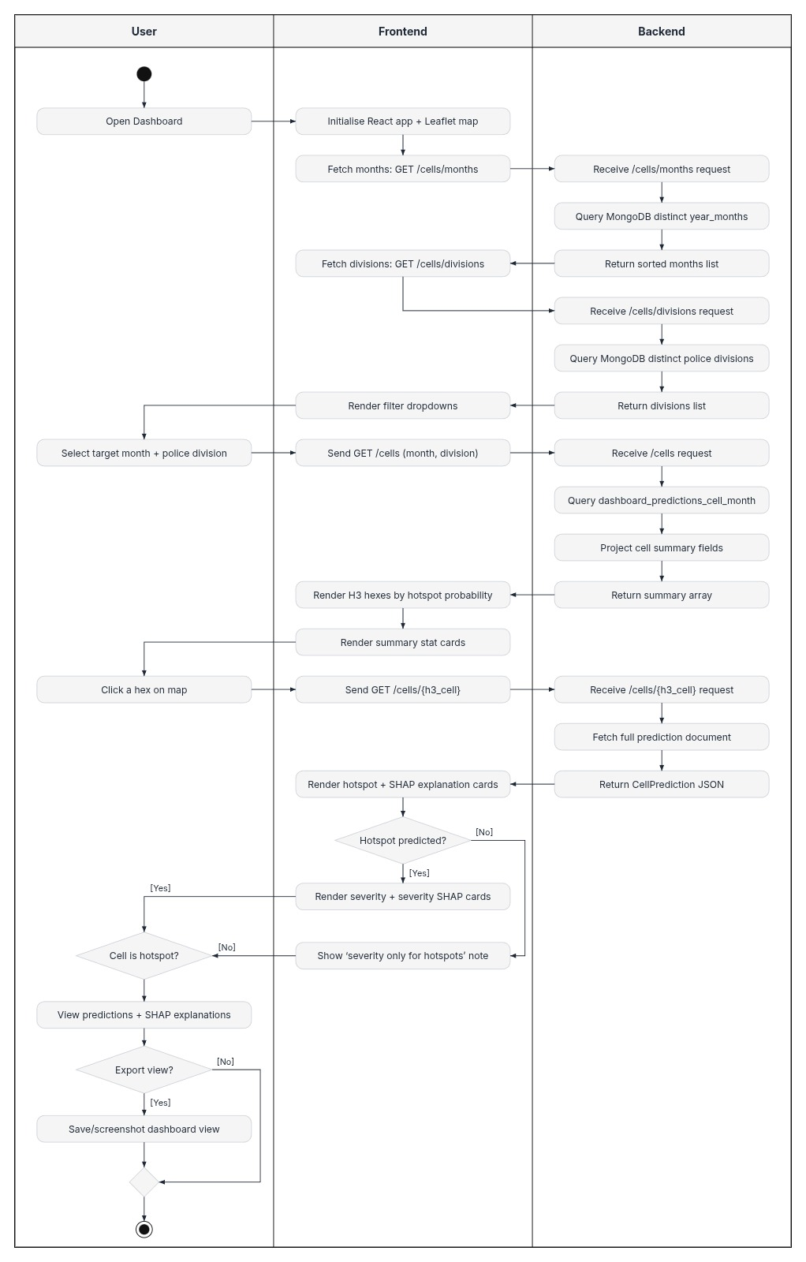
Figure 8 Activity Flow Diagram

4.5.4 User Interfaces
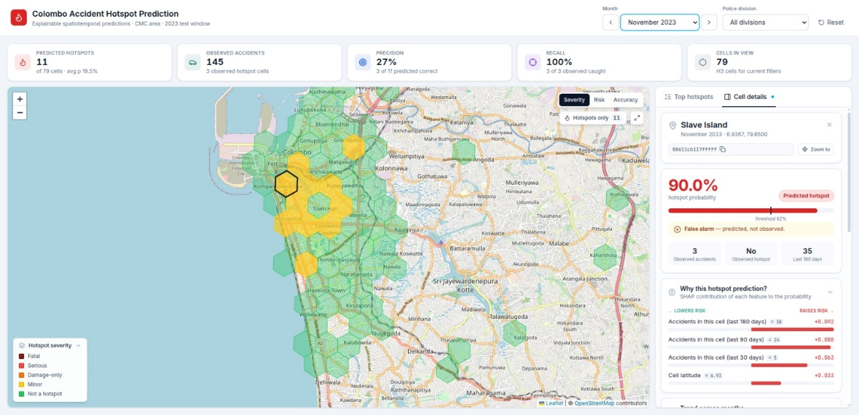
Figure 9 Accident Hotspot Prediction and Severity Classification Dashboard

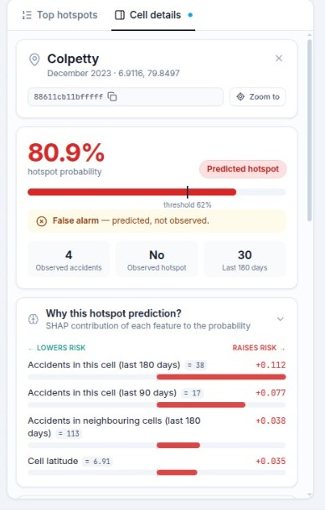
Figure 10 Hotspot Prediction Probability and SHAP Explanations

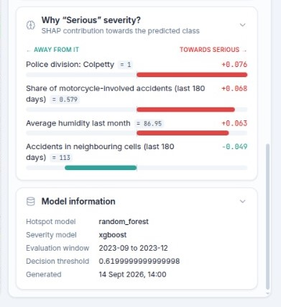
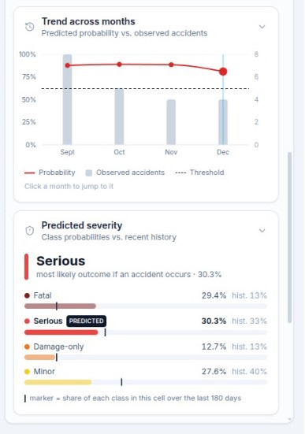
Figure 11 Severity Prediction Probability and SHAP Explanations

4.6 Algorithms/Models

4.6.1 Algorithms
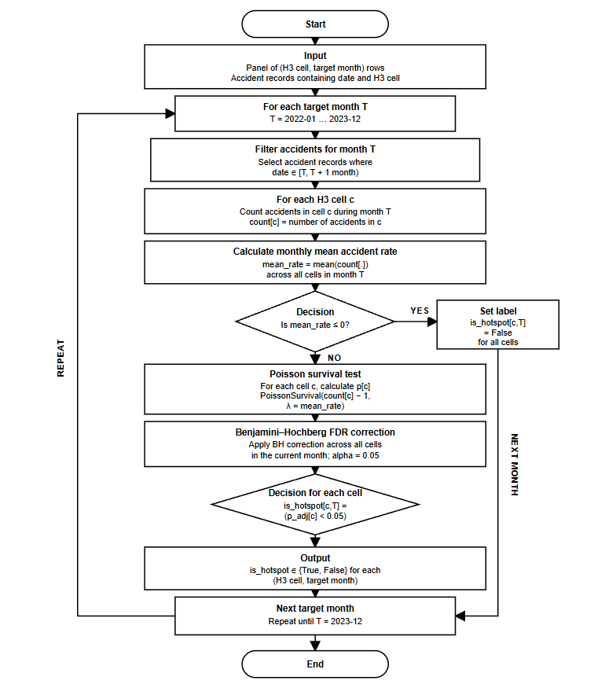
Figure 12 Hotspot Identification Algorithm

4.6.2 Models

Random Forest (Hotspot Classifier)

For the hotspot classification, Random Forest was chosen as candidate model, which recorded highest pooled rolling validataion F1-Score of 0.4945 compared to 04813 by XGBoost and 0.3697 by logistic regression. Accordingly, the model works by combining predictions from multiple decision trees that were trained on different bootstrap of sample of training data and for this specific task we have used 300 decision trees (n_estimators = 300). In here, each tree, learn patterns form the relevant input features and then the model averages their predicted probabilities to get the final prediction.
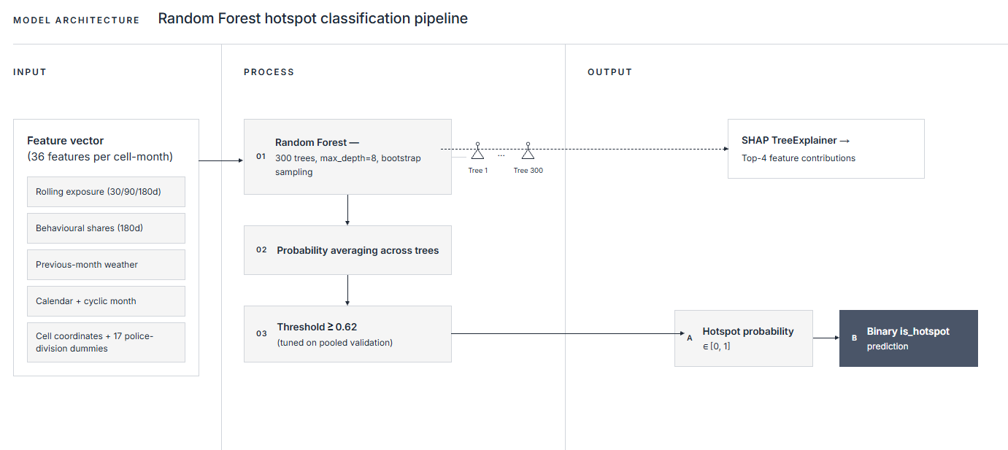
Figure 13 Random Forest (Hotspot Classifier)

XGBoost (Severity Classifier)

For the severity classification, XGBoost was chosen as candidate model, with the highest mean rolling validation macro F1-Score of 0.2583 compared to 0.2320 by Random Forest and 0.1933 by logistic regression. In addition to these XGB also had the lowest variations in macro F1 across validation folds. Accordingly, XGBoost works by building groups of decision trees in a sequential way and allowing each new tree to improve the predication made by its previous tree. Finally, XGBoost combine all these predictions to estimate the probability of severity classes of a given hotspot.

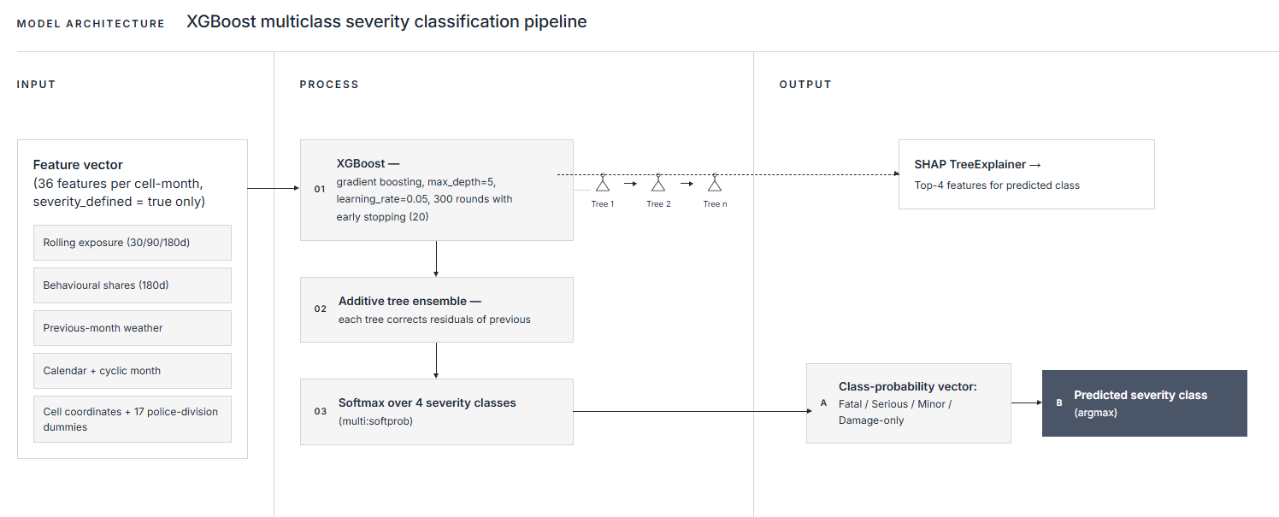
Figure 14 XGBoost (Severity Classifier)

4.7 Dataset / Data Preparation
When it comes to datasets, this research uses 3 typed of data sources which includes real accident records, empirical data sources for synthetic data generation and weather data obtained from Visual Crossing weather API.

Slave Island Police Station Accident Records
One of such data source is historical accident police records obtained from Slave Island police station for the year 2022. Accordingly, these accidents records included features such as accident location, date and time, severity, vehicle type, cause, fatalities and injuries, which helped to get an understanding of features related to road traffic accident data in Sri Lanka.

Synthetic Accident Data Generated using Sri Lankan empirical literatures
As mentioned earlier, due to the limitations in extraction of real historical accidents data, it was planned to generate synthetic data to demonstrate how the framework works while scoping the study to lambda contribution. Accordingly, a structured synthetic data generation pipeline that uses Sri Lankan empirical sources to identify features related to Sri Lankan accidents and accident distribution have been implemented. Also those synthetic data were then validated using techniques like Chi Square and joint dependency tests.. The relevant sources are as follows.

Source | Fields Anchored
(“Department of Census and Statistics,” 2024) | Road accident distribution across Colombo Municipal Area
(“2025 Traffic Reports – SRI LANKA POLICE,” 2025) | National Severity Mix related to road traffic accidents (Fatal, Serious, Damage-Only, Minor)
(W. G. S. R. Thilakarathna et al., 2025) | Time of day and cause distributions for accident with fatal severity
(Jayasinghe et al., 2025) | Time of day and cause distributions for accident with non fatal severity
(Boeing, 2025) | Street name vocabularies for Colombo Municipal Area
Table 6 Empirical Sources

Weather Data via Visual Crossing Weather API
Weather data needed for the study were obtained from Visual Crossing Weather API (Weather Data & Weather API | Visual Crossing, n.d.). This included daily weather data that covers the Colombo area for the time period of 2022 to 2023. Such data were then aggregated to into monthly featured during the implementation of training panel for model training, providing weather information for spatiotemporal analysis and prediction tasks.

4.8 Technology Selection
Technology | Version | Relevance to this research
Python | 3.11 | Act as the primary language for the framework as python can be used for every core component such as ETL pipeline, modelling and explainability.
MongoDB Atlas (cloud) | 8.0 | Because it enables handling of large amount of data such as accident and weather data without any rigid scheme through document oriented storage.
h3-py: Uber's H3 Hexagonal Hierarchical Geospatial Indexing System in Python | 4.5.0 | Enables hexagonal indexing of location data under resolution 8, enabling overall spatiotemporal analysis
Google Map API | N/A | Enables conversion of location names into longitudes and latitudes
Visual Crossing Weather API | N/A | Provides historical weather data from 2022-2023 for Colombo region
SciPy + statsmodels | 1.18.1 / 0.15.0 | Enabled implementation of Poisson survival test and Benjamini-Hochberg FDR correct for hotspot identification.
Scikit-learn | 1.9.1 | Enables implementation of Logistic Regression and Random Forest models. It also provides functions needed for leakage safe preprocessing, dataset splits, and for metrics used by all 3 models
XGBoost | 3.4.1 | Enables implementation of XGBoost model.
SHAP | 0.52.0 | Contribution of features explanations for a prediction via TreeExplainer
FastAPI | 0.14.1 | Implementation APIs that retrieves outputs of the artefact from Mongo Atlas collection and sever them to frontend dashboard.
React | 19.3.0 | Implementation of frontend dashboard that visualizes outputs of the artefact such as predications and their SHAP explanations
Leaflet + React-Leaflet | 1.9.4 / 5.0.0 | Enables rendering of H3 polygons on OpenStreetMap tiles of the Colombo Municipal region.
Table 7 Technology Selection

4.9 Implementation
Under DSR Lambda contribution, which was mentioned in earlier chapter, the output of the framework is only a demonstration of multisource explainable and spatiotemporal model for hotspot prediction and severity classification can be implemented. Therefore, only a prototype demonstration of the methodology is implemented rather than a production system that is ready to be deployed in authorities such as Sri Lankan police.

Accordingly, implementation mainly consists of 2 main parts, which is an offline machine learning pipeline and online delivery layer. In here, machine learning pipeline is responsible for tasks like data preprocessing and feature engineering though the ETL pipeline, model training and evaluation and generation of cell level predictions along with SHAP explanations and saving them to relevant mongo collections, while online delivery layer is responsible for visualizing such outcomes of the framework though the prototype dashboard by retrieving them from relevant mongo collections. Overall, implementation can be divided into 3 phases as ETL and spatiotemporal training panel construction, machine leaning model training and evaluation along with SHAP explanations, and presentation of output though the dashboard and APIs.

Furthermore, during implementation 3 main factors were taken into consideration. One such point is data scarcity due to lack of a centralize data management system for traffic accident related data in Sri Lanka. As a result, framework is designed in a way that it enables regeneration of training panel and prediction from raw data when additional real accident records are available. Another major consideration was reproducibility of the framework. Accordingly, techniques like Randon Seed have been used to make sure that training panel structure remain same when the inputs provided are same. In addition to that important information such as fitted preprocessor, feature schema, decision threshold and training timestamp are saved to model bundles, preserving model configuration, allowing repeating of prediction process under same conditions. The last important consideration was prevention of data leakage during model training. Accordingly, by applying preprocessing only to training data in each validation fold and final test evaluation data leakage was prevented. In addition to that, data from September 2023 to December 2023 were never used for processes such as model selection, threshold tuning, preprocessing fitting or XGBoost early stopping as data belong to that time period comes under test split and holding out such data like this make sure that they don’t influence model training and evaluation, thus preventing data leakage.

When it comes to implementation environment, no dedicated police infrastructure is required as this is a prototype implementation that follows DSR lambda contribution. Therefore, local research environment consisting of main technologies such as Python 3.11, MongoDB Atlas, FastAPI, React, scikit-learn, XGBoost and SHAP was used for the implementation of the framework.

4.10 Chapter Summary
In this chapter, we explored the design and implementation of the proposed traffic accident hotspot prediction and severity classification framework. Accordingly, main requirements, system architecture, models, dataset, technologies, and implementation process of the prototype artefact were discussed.

The chapter started by defining function and non functional requirements which were gathered based on objectives, research gap and practical constraints identified during the earlier stage of the research. Once requirements were defined, then the system architecture for the proposed solution along with a diagram was explored. Accordingly, the architecture consists of 5 layers which are data source , ETL and feature engineering, data storage, modelling and explainanility and deliver layer.

The chapter then explored the main algorithms which include hotspot identification algorithm and candidate machine learning models among logistic regression, Random Forest and XGBoost used in the framework. Accordingly, Random Forest was chosen as candidate model for hotspot prediction while XGBoost for severity classification.

The chapter also discusses the datasets used for the development of the artefact. Such datasets include real collected slave island police station data, synthetic data generated using Sri Lankan empirical literatures and Visual Crossing weather API. Moreover it also discussed the main technologies that we used for the implementation of the framework

The ends by discussing about the overall implementation process of the artefact which covered the ETL and training panel construction, model training and SHAP integration and prototype dashboard development for the visualization of the results. Also, actions taken to improve reproducibility and prevent data leakages were also discussed. In conclusion, this chapter explain how the proposed artefact was constructed along with its main components and system designs.

Chapter 5: Evaluation and Results

5.1 Introduction
In the last chapter, we discussed the design and implementation of the framework by exploring factors like requirements, system architecture, algorithms and machine learning models, and delivery layer. However, the framework still needs to be evaluated to ensure whether it achieves those defined objectives and satisfies the requirements. Accordingly, this chapter evaluates the framework using 4 main areas, which include functionality evaluation that assesses whether the requirements were achieved, data fidelity evaluation which assess whether the synthetically generated data faithful to adheres to statical distribution of empirical sources, technical evaluation that explores the performance evaluation of machine learning models and usability evaluation of the dashboard.

However, as mentioned in earlier chapters, the study is scoped to lambda contribution. Therefore, the framework is not claiming any ground truths or operation level performance that enables direct deployment to authorities like Sri Lanka Police. Instead, the goal is to deliver the framework as a proof of concept, demonstrating that the proposed methodology can be implemented, tested, and delivered as a prototype that adheres to the Sri Lankan context. Accordingly, this chapter explores the evaluation framework that is designed according to these needs.

5.2 Evaluation Framework
As mentioned in earlier, the evaluation framework is divided into 4 parts, where each focuses on different aspect of the framework and helps us to ensure whether the framework achieves the defined objectives. Accordingly, 3 parts of the evaluation framework and their intended purposes are given below.

- Functionality
  - This part of the evaluation framework helps us to assess whether the developed artefact achieves the functional requirements mentioned in section 4.2. Accordingly, it was decided to incorporate test cases to check whether the component of data pipeline, modelling and delivery layer work as expected. Overall, this part evaluates whether the framework can complete defined requirements from data preprocessing layer to the dashboard.

- Data Fidelity
  - This part assesses whether the distribution of synthetically generated data matches to the original distribution obtained from 5 empirical sources. In addition to that independence tests will be used to evaluate the conditional rules that we used to establish relationship among variables during synthetic data generation.

- Technical Accuracy
  - This part helps to evaluate the performance of trained machine learning models using the held out temporal test split of the dataset which covers the time period of September to December 2023. Accordingly, for this, evaluation metrics like F1-score, ROC-AUC, average precision and per-class performance can be used. In addition to temporal split, we also use a group split to check whether the model can predict hotspot and severity status of cells that haven’t been included in the training data.

- Usability
  - This part of the evaluation framework is responsible to assess whether the developed dashboard can be used by a non-technical person. However, with the given time it is unable to test the dashboard with the Sri Lankan Police. Therefore, it was decided to evaluate the dashboard by the researcher using a small set of Nielsen’s usability heuristics, which were customized to this specific purpose.

Overall, this evaluation framework helps us to assess whether the developed framework conforms to its requirements while also evaluating its performance as a prototype in technical and usability aspects.

5.3 Evaluation Criteria
Evaluation Component | Criteria | Measurement | Instrument
Functionality | Implementation of functional requirements mentioned in section 4.2 | Number of test cases passed vs executed | Scripted test cases that covers defined functional requirements.
Marginal Evaluation of data Fidelity | How similar the statical distribution of the synthetic data are to the original empirical sources | Chi-square goodness-of-fit p-values | Per-feature χ² test against each anchored source
Conditional Rule Evaluation of data Fidelity | Generator's R1/R2/R3 conditional rules preserve the intended joint dependencies | Chi-square Independence p-values | Per-rule χ² test on severity conditioned on the rule's trigger slice
Accuracy of Hotspot prediction | Model’s ability to identify hotspots cells from non hotspot cells. | F1, ROC-AUC, average precision, confusion matrix | Pooled rolling temporal validation and untouched 4-month test window
Accuracy of Severity prediction | Severity classifier’s ability to predict severity of a given cell without just outputting the most common severity class | Macro-F1, per-class F1, per-class precision/recall | Perform evaluation on above mentioned held out test data of the temporal split
Usability (Heuristic) | Dashboard designed in such a way that it follows established usability heuristics when presentation predictions and explanations | Pass / partial / fail against each heuristic | Solo expert walkthrough
Comparison | Comparing proposed framework to existing ones to find differences | Comparison of features of proposed system against existing studies | Comparison Table in section 5.9
Table 8 Evaluation Criteria

5.4 Experimental/Test Results
In order to check whether the framework is working as expected, it was decided to covert functional requirements defined in section 4.2 to executable test cases. Those test cases were then executed against the developed pipeline, covering the stages from data preprocessing via ETL pipeline to delivery layer. Accordingly, if the relevant components of each stage were able to satisfies the relevant test case, then such test cases were marked Passed.
Functional Requirement | Test Case | Expected Outcome | Result
FR 1 | Execution of ETL pipeline once input and accident data and Visual Crossing Weather API data | Population of raw accident and weather collections in Mongo Atlas while also enabling joining of both data based on the date and location | Pass
FR 2 | Generation of synthetic data base on the statistical distribution of accidents obtained from Sri Lankan empirical sources | Historical accident dataset with around 3688 records with statical distribution matching to relevant empirical sources | Pass
FR 3 | Generation of cell month training panel based on H3 indexing with resolution 8 and rolling pre cut off window | Train panel consisting of 1896 rows (79 cells $×$ 24 months) and calculated 30/90/180 rolling features using data available before the target month | Pass
FR 4 | Calculation hotspot labels using Poisson and Benjamini–Hochberg FDR | Identification of cell month panels with unusually high accident count using Poisson Testing and application of Benjamini-Hochberg FDR with a $α$ = 0.05 to cell month panel with unusual traffic accident count to identify potential hotspots | Pass
FR 5 | Training and evaluation of LR, RF and XGBoost models | Once, 3 models are trained for each classifications task, it is expected to have a best performing model for each tasks as candidate models, which was chosen based on combined rolling validation results | Pass
FR 6 | Generation of SHAP explanations for both hotspot prediction and severity classification | SHAP TreeExplainer integrated to each candidate model should output top 4 features contributed to a certain prediction | Pass
FR 7 | Visualization of predictions through REST APIs and the dashboard | Developed 7 REST endpoint should return the expected responses and reach leaflet dashboard should visualize hotpot H3 cells along with their severity and XAI explanations | Pass
Table 9 Test Results

5.5 System Performance Results
When it comes to system performance, the dashboard and relevant APIs were evaluated by sending 20 sequential requests for each endpoint. Accordingly, the dashboard is deployed using Vercel and MongoDB Atlas and the system performance results are as follows.
Endpoint | What the request returns | Average response time (ms) | 95th percentile response time (ms)
GET /cells?year_month=… | Summary of all 79 cells for the month, used for map rendering | 717 | 784
GET /cells/{h3_cell}?year_month=… | Single document lookup for the selected-cell detail panel | 498 | 514
GET /hotspots?year_month=… | Cells predicted as hotspots, sorted by hotspot probability | 711 | 760
GET /severity/{h3_cell}?year_month=… | Single-document lookup, limited to the severity prediction | 506 | 548
GET /xai/{h3_cell}?year_month=… | Single-document lookup, limited to the SHAP features | 503 | 550
Dashboard initial load (repeat visit) | Time from the start of navigation until the initial map data is received. | 1,758 | 1,824
Dashboard initial load (first visit) | Same measurement with an empty browser cache | 2,815 | –
Table 10 System Performance Results
However, it is very important to understand that this performance only reflects the performance of the prototype that is developed as a proof of concept. Therefore, such performance should not be considered as production level performance

5.6 Synthetic Data Evaluation

Accordingly, features in synthetic data were evaluated against their empirical source using Chi-square goodness-of-fit tests (α = 0.05) and their results are as follows.

Attribute tested | Empirical source | χ² (df) | p-value | Result
Severity (before rules) | (“2025 Traffic Reports – SRI LANKA POLICE,” 2025) | 3.93 (3) | 0.270 | Match
Severity (after rules) | (“2025 Traffic Reports – SRI LANKA POLICE,” 2025) | 97.71 (3) | < 0.001 | Differs (intended)
Severity (Slave Island) | (“2025 Traffic Reports – SRI LANKA POLICE,” 2025) | 7.67 (3) | 0.053 | Match
Time of fatal accidents | (W. G. S. R. Thilakarathna et al., 2025) | 4.47 (3) | 0.215 | Match
Time of non-fatal accidents | (Jayasinghe et al., 2025) | 3.67 (4) | 0.453 | Match
Cause of fatal accidents | (W. G. S. R. Thilakarathna et al., 2025) | 11.18 (8) | 0.192 | Match
Cause of non-fatal accidents | (Jayasinghe et al., 2025) | 5.03 (8) | 0.755 | Match
Collision type | (W. G. S. R. Thilakarathna et al., 2025) | 2.33 (3) | 0.507 | Match
Driver age group | (W. G. S. R. Thilakarathna et al., 2025) | 9.14 (6) | 0.166 | Match
Table 11 Synthetic Data Evaluation

Based on the above results, it is clear that generated attributes mostly have a distribution similar to their sources other than “Severity”. However, that deviation is expected as some conditional rules (R1-R3) were applied to create meaningful relationship among such variables. For example, such relationships were statistically significant for night-time accidents, motorcycle or pedestrian involvement, and alcohol-related causes (p < 0.001). However, it is very important to understand that these results still don’t confirm that this is real world distribution. It’s rather a demonstration of the statistical feasibility of generated features to their empirical sources

5.7 Accuracy/Precision/Recall or Other Technical Measures
As mentioned earlier, this framework is only developed as proof concept under lambda contribution rather than claiming deployment ready model performance. Therefore, the model evaluation is only there as a demonstration of how proposed methodology can be evaluated using leakage-safe temporal testing, model comparison and different performance measures. Additionally, future works can incorporate this exact model evaluation methodology, when it comes to developing a deployment ready framework. Accordingly, below evaluation results are based on synthetic data generated. Therefore, limitations of this study needs be considered when interpreting such results.

5.6.1 Hotspot Classification Results based on Temporal Test Window

Metric | Logistic Regression | Random Forest (selected) | XGBoost
Pooled validation F1 | 0.370 | 0.495 | 0.481
Test F1 | 0.522 | 0.491 | 0.429
Test ROC-AUC | 0.940 | 0.957 | 0.946
Test average precision | 0.478 | 0.478 | 0.382
Test precision | 0.387 | 0.333 | 0.293
Test recall | 0.800 | 0.933 | 0.800
Decision threshold | 0.83 | 0.62 | 0.23
Table 12 Hotspot Classification Results
When it comes to hotspot classification Random Forest was chosen as candidate model as it was able to identify 14 out of 15 actual hotspot with 28 false positive, which resulted in moderate F1-Score of 0491. These low scores could be due to test set cell month panel only being consisting of 15 hotspot cells out of 316 total cell month panel. However, it still achieved the highest ROC-AUC among other models with a score of 0.957, demonstrating that model can still rank hotspot vs non-hotspot cases. Also, as previously mentioned, these scores only there to demonstrate how framework can be evaluated rather than claiming real world performance.

5.6.2 Severity Classification Results based on Temporal Test Window

Metric | Logistic Regression | Random Forest | XGBoost (selected)
Mean validation macro-F1 | 0.193 | 0.232 | 0.258
Test macro-F1 | 0.195 | 0.185 | 0.236
Test accuracy | 0.272 | 0.236 | 0.328
F1 – Fatal | 0.107 | 0.063 | 0.063
F1 – Serious | 0.051 | 0.231 | 0.362
F1 – Minor | 0.457 | 0.362 | 0.444
F1 – Damage-only | 0.163 | 0.085 | 0.074
Table 13 Severity Classification Results
When it comes to severity classification XGBoost was chosen as candidate model as it was able to achieve highest macro-F1 score of 0.258 among 3 models. In addition to that, it achieved accuracy of 0.328 and test-F1 score of 0.236. Accordingly, it is clear that model performance every low when it comes to severity classification, demonstrating that relevant models were unable to significant relationships among variables. The main reason for this could be due to lack relationships among location and spatiotemporal features in synthetic data. Also, generated synthetic data had a sever class imbalance for severity values such as “Fatal: and “Serious”, which also contribute to such low performance. Therefore, these result are also only there to demonstrate a evaluation methodology rather than claiming any ground truths related to road accidents in Sri Lankan context.

5.8 User Evaluation
Due to this study being a lambda contribution where it demonstrates framework like this can be implemented in Sri Lankan context rather than claiming any ground truths or deploying policy ready dashboard, it was decided to exclude formal user evaluation using targeted users of the dashboard such as Sri Lankan Police. In addition to that, such endeavors require more formal effort which requires more time beyond the deadline. Accordingly, the study is only evaluates using functional, technical, and heuristic evaluation while keeping formal user evaluation for future works.

5.9 Usability Evaluation
When it comes to usability evaluation it was decided to incorporate reduced set of Nielsen’s usability heuristics against dashboard. Accordingly, there specifically designed for prediction and explanation tasks of the dashboard and are as follows

Heuristic (specialized) | Result | Note
Visibility of system status - the user knows the month, division and cell being viewed | Pass | Month/division selectors and selected-cell details are visible
Match between system and the real world – Visualization of prediction via plain human language | Partial | Even though feature labels are in understandable language, technical details such as raw SHAP values and prediction threshold in model details section aren’t that user friendly
User control and freedom - filters can be changed without data loss or inconsistent state | Pass | Filters can be changes or reset by users without any barriers. In addition to this the URL also preserve current view of the dashboard
Consistency and standards in visuals | Partial | Colors used to visualize probabilities of predictions and severity are consistent. However, there are some inconsistencies in color scheme used to represent SHAP explanations
Aesthetic and Minimalistic Design – Unnecessary clutters in default view | Partial | The dashboard efficiently use collapsible sections to avoid clutters. However, map is zoomed out when loading the dashboard, causing hexagon cells to appear small.
Assist users to recognize, diagnose and recover form errors through reporting of failures and missing data | Partial | API failures and empty results are transparently handled by the dashboard. However, if a user input invalid month to URL manually, it fallbacks to first month without being transparent about the problem
Explainability sincerity (added check beyond Nielsen’s original heuristics) - SHAP direction reflects contribution sign | Pass | SHAP explanations correctly visualize how certain features increase or decrease the probability of a prediction
Table 14 Heuristics Usability Evaluation

5.10 Comparison with Existing Solutions

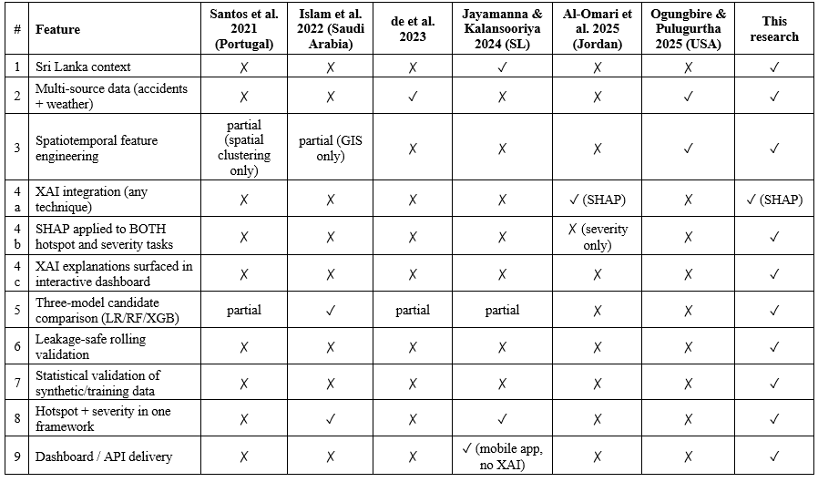
Figure 15 Comparison with Existing Solutions

5.11 Results Related to Research Objectives

Results related to objectives defined in chapter 1 as follows

- Objective 1 – Derive Spatiotemporal Features for Accident Hotspot prediction and Severity Classification
  - The developed feature engineering pipeline able to satisfy the first objective by developing a cell month training panel consisting of spatiotemporal features such as accident locations, historical timeline of accidents and weather information. Additional spatiotemporal features such as rolling 30-, 90- and 180-day accident measures, 180-day behavioural shares and lagged monthly weather features prior to targeted prediction month were also generated, ensuring further spatiotemporal analysis.
- Objective 2 – Training and Evaluation of Logistic Regression, Random Forest and XGBoost to identify candidate model for each prediction task
  - This was also addressed by using a leakage-safe rolling temporal validation procedure for all 3 models, ensuring consisting evaluation. As mentioned in section 5.6 Random Forest was chosen as the candidate model for accident hotspot prediction task while XGBoost for severity classification. Also such model were chosen based on validation results, keeping test split for further independent assessment.
- Objective 3 – Development of a Framework for Accident Hotspot Prediction and Severity Classification
  - Once candidate models were chosen, they were integrated to the pipeline, developing a framework capable of accident hotspot prediction and severity classification. Additionally, a way to visualize outputs of the framework were also developed through the incorporation of react leaflet dashboard.
- Objective 4 – Integration of XAI techniques to Prediction Pipeline to ensure Transparency and Interpretability
  - To achieve this objective, SHAP TreeExplainer was integrated to candidate models, allowing it to explain top 4 feature contribution for a prediction. Such explanations were then output to users via the developed dashboard.

5.12 Chapter Summary

In this chapter, we explored the ways that can be used to evaluate the designed framework and it was decided to divide the evaluation framework into 4 parts as functionality, data fidelity, technical performance, and dashboard usability assessments. Accordingly, the framework is able to satisfy all the functional test cases that were defined based on functional requirements. Also, data fidelity evaluation is used to scrutinize whether the synthetic data preserves the original statistical distribution of empirical sources. The chapter then evaluated the performance of the prototype that was deployed on Vercel and MongoAtlas.

Furthermore, chosen machine learning models were also evaluated to choose candidate models for each prediction task. Accordingly, Random Forest was selected for hotspot prediction task while XGBoost was selected for severity classification task. However, the chapter also explained that these results were only used to demonstrate the feasibility of the framework rather than claiming any ground truths as the framework itself was designed as a proof of concept under DSR Lambda contribution. In addition to these, the chapter evaluated the developed dashboard using a customized set of rules based on Nielsen usability principles.

Once these sections were evaluated, the chapter then compared the results with the objectives of the research, demonstrating overall technical and methodological feasibility of the proposed framework within Sri Lankan context. However, due to this study being lambda contribution and certain limitations such as data scarcity, it is very important to understand that these evaluations do not claim any ground truths but rather provide an evaluation framework for the proposed methodology that is developed as a proof of concept.

Chapter 6: Discussion, Conclusion and Recommendations

6.1 Introduction

In last chapter, we explored the evaluation framework which consists of parts such as functionality, synthetic data fidelity, model performance, technical performance and dashboard usability evaluation which was designed for the developed framework. Accordingly, this chapter explores findings from such evaluations and their relationships to defined research objectives and questions. In addition to those the chapter also includes recommendations based on findings and future works that can be carried by other researchers. Finally, chapter will include a conclusion section which summarizes the overall research, highlighting its main contributions and limitations.

6.2 Discussion of Findings

- Finding 1: The framework demonstrates that it is feasible to integrate multiple data source for accident hotspot prediction tasks.
  - Accordingly, the proposed framework merges generated accident records with weather data obtained from Visual Crossing weather API via the ETL pipeline to construct the training panel needed for relevant machine learning models. Results of such stages prove that the framework can technically combine multiple data sources to prepare them for further stages such as spatiotemporal analysis and machine learning model training. However, as the framework uses synthetic data, it is very important to understand that some modification will be needed when it comes to handling real world accident records.

- Finding 2: Framework did able to preserve selected statistical distributions from empirical sources
  - Synthetic data evaluation using chi-square tests which was discussed in section 5.6 shows that most of the selected variables able to preserve original statistical distribution of their empirical sources. Accordingly, only the “severity” variable did deviate from the original and distribution and that was because of the introduced conditional rules (R1-R3). However, such data still doesn’t represent any real world accident distribution and only used for the demonstration of the proposed framework.

- Finding 3: Hotspot classifier performed well in ranking accident risks but still false positive remains a limitation
  - After training and evaluating machine learning models for accident hotspot prediction task, Random Forest was chosen as candidate model based in it’s rolling validation F1-score of 0.495. In was able to identify 14 of the 15 actual hotspot during test split evaluation. However, 28 false positives were produced by the model resulting moderate F1-Score of 0.491. This can be mainly due to the usage of synthetic data and lack of enough data for test split . However, such results doesn’t ensure that this model is ready for deployment as the framework itself is a lamnda contributon.

- Finding 4: Weak performance by severity classifier
    - Even though XGBoost was selected as the candidate for model for severity classifier, its performance was weak with a test macro-F1 of 0.236, highlighting that current feature set is not enough for learning patterns related to severity of accidents.

- Finding 5: Recent accident history and location contributed most to hotspot predictions.
  - When it comes to the prototype of the proposed framework which was developed as proof of concept, it was found that features such as recent accident counts in the same cell and neighboring cells, along with location, contributed most to hotspot predictions. However, features like weather information didn’t contribute much to predictions. But this could be due to accident data being synthetic while weather data was real world data. Therefore, it is very important to interpret this demonstration of feature contribution of prototype rather than real world feature contribution

- Finding 6: The prototype provides explainable predictions, but the explanations need to be more human.
  - Even though REST endpoints and dashboard passed the functional testing, heuristic evaluation identified some room for usability improvements in the dashboard. Accordingly, main issue identified was that SHAP explanations were too technical. Therefore, future works can make such explanations more human.

6.3 Achievements of Research Objectives

- Objective 1 - To feature engineer the spatial, temporal and weather parameters from the combined accident data and weather data for the development of spatiotemporal model training panel.
  - This was achieved by indexing combined weather and accident data into H3 cells (via hexagonal indexing) with resolution 8 and ordered by month, creating a training panel of 1,896 rows (79 cells × 24 months). Additionally, more spatiotemporal features such as Rolling 30-, 90- and 180-day accident counts, neighboring-cell counts, behavioral shares and previous-month weather features were generated based on the data available before the month that is supposed to predict. Hotspot labels were then assigned to H3 cells using Poisson testing with Benjamini–Hochberg FDR

- Objective 2 – To train and evaluate Logistic Regression, Random Forest and XGBoost to identify a candidate model for hotspot prediction and severity classification tasks.
  - All 3 models were trained and evaluated to find the candidate models for each predicted task using leakage-safe rolling temporal validation approach. Accordingly, Random Forest was chosen for hotspot prediction task and XGBoost for severity classification. However, such results need to be interpreted under lambda scoping as they only demonstrate frameworks capabilities rather than real world predictive accuracy

- Objective 3 – To integrate Explainable AI techniques into prediction pipeline as it helps to improve transparency and interpretability of predicted results
  - Once both candidate models chosen for accident hotspot prediction and severity classification tasks were trained, SHAP TreeExplainer was then integrated to both models, allowing such models to identify top 4 features contributed to a certain prediction, improving transparency of overall framework

- Objective 4 – To design and develop a complete reusable machine learning framework for traffic accident hotspot prediction and severity classification
  - Once models were trained and integrated with XAI techniques, then they were integrated into the framework, enabling accident hotspot prediction and severity classification capabilities. The prediction results were then save to collection MongoAtlas, allowing a prototype dashboard to visualize outputs of the framework

6.4 Answers to Research Questions

- Research Question 1 - How can spatial, temporal, and weather features be engineered from accident and weather data to develop a spatiotemporal model training panel?
  - By indexing combined preprocessed accident records and weather data into H3 cell with resolution 8, we were able to extract main spatiotemporal features needed. In addition to them, spatiotemporal features such as Rolling 30-, 90- and 180-day accident counts, neighboring-cell counts, behavioral shares and previous-month weather features were generated based on the data available before the month that is supposed to predict, providing features needed for training panel contruction
- Research Question 2- What is the best machine learning model among Random Forest, Logistic Regression, XGBoost, when it comes to accident hotspot prediction and severity classification?
  - Random Forest was chosen for hotspot prediction task and XGBoost for severity classification. However as mentioned earlier, such results need to be interpreted under lambda scoping as they only demonstrate frameworks capabilities rather than real world predictive accuracy
- Research Question 3 - How can Explainable AI techniques be integrated into the prediction pipeline to understand feature contribution to a certain prediction and thereby to improve the transparency and interpretability of the framework?
  - By integrating SHAP TreeExplainer to both candidate model, the framework was able to identify top 4 features contributed to a certain prediction. Such information were then save in a Mongo Atlas collection, enabling visualization of feature explanation through dashboard.
- Research Question 4 - How can a reusable machine learning framework be designed and developed for traffic accident hotspot prediction and severity classification?
  - By designing the framework into 5 independent layers which supports both modularity and reproducibility. Additionally, prediction and SHAP explanation outputs of the framework were visualized through a prototype dashboard. However, the outputs of the framework should only consider as demonstration under lambda scoping rather than real world representation accident distribution.

6.5 Recommendations

Based on the finding of the research, it was decided to provide following recommendations for future researchers who conduct study on this area and authorities that are responsible for handling road traffic accident

- Recommendation 1- Digitization and implementation of central data management system for police accident records
  - Accordingly, the main limitation of this research is data scarcity. Even though we were able to collect sample data records from Slave Island police station to understand the structure of such data, it wasn’t enough for model training, which led us to generate synthetic data and scope the framework to DSR lambda contribution. However, Sri Lanka is considering digitization of accident records, but the process is still in a transitional stage, where most of the police stations manage those records via physical books. Therefore, this study highly recommends that relevant authorities implement a data management system for accident records, allowing more statistical analysis of accident records and thereby reducing its negative impacts.

- Recommendation 2 – Usage of monthly cell-level risk rankings to plan patrols and interventions.
  - Once the deployable version of this framework developed and validated using real world data, authorities such as Sri Lankan police can incorporate it into their workflow, enabling them to view monthly ranked list of high-risk H3 cells and prioritize top rank cells for patrols and safety inspections.

- Recommendation 3 - Consideration of additional features for severity classification
  - Based on the result of this study, it was clear that performance of severity classifier is weak. This could be due to usage of synthetic data lack of enough features for a model to learn patterns related to severity. Even though problems caused by synthetic data can be addressed by Recommendation 1, model still need enough features to learn severity patterns. Accordingly, as a recommendation, features such as road type, junctions, lighting and speed limits can be incorporated to address these problems.

- Recommendation 4 – Presentation of SHAP explanations in a more humanized way
  - So dashboard visualize SHAP explanation in a more technical way it is just a prototype develop for the demonstration of framework. However, when developing deployment ready version of the prototype, it is very important present such explanations in a way that a non technical user can understand. For example, presenting using sentences like “accidents in this area increased sharply in the last 90 days” can reduce this traction between user and dashboard.

6.6 Future Research

Future researchers can use the same pipeline, including its feature design and evaluation framework. However, certain improvements can be done to the framework to take it from Lambda contribution to Omega contribution. One such thing is using real using real digitized accident records that represent real world accident distribution. By doing this, we can make sure that the framework is deployable with a real candidate model trained on actual data. Also, future studies can integrate additional features such as road type, junctions, lighting and speed limits, which help models to understand more patterns. AS mentioned earlier, this may also help to fix the weak performance by severity classifier as such features enable models to learn more relationships about the severity status of accidents. Furthermore, future studies can extend the framework in a way that it covers whole Sri Lanka instead of just the Colombo Municipal Area. Also improvements such as multi agent decision systems that can provide recommendations to users based on the SHAP explanation can be considered and integrated to the framework.

6.7 Conclusion

The study aimed to develop an explainable multi-source spatiotemporal machine learning framework for traffic accident hotspot prediction and severity classification for Sri Lankan context. The framework first creates the ETL pipeline by merging generated synthetic data with weather data and indexing them to H3 cells for spatiotemporal analysis. Then as the final step of the ETL pipeline, a spatiotemporal training panel was built, enabling training and evaluation of 3 machine learning models. Once such models were evaluated, a candidate model for each task using the chosen and SHAP TreeExplainer was integrated to each candidate model, allowing them show feature contribution to a certain prediction. In addition to this synthetic data evaluation showed that most of the selected attributes, except “severity” attribute match their empirical sources. Also, mismatches occurred to “severity” attribute was expected due to introduced conditional rules. As the final step, outputs of the framework were visualized through REST APIs and a prototype dashboard.

Accordingly, the study mainly explored 3 main gaps identified, which are reliance on a single data source, limited spatiotemporal modelling and the lack of explainable AI in Sri Lankan accident prediction and proposed a reproducible framework to address such gaps. However, the study is scoped to Lambda contribution due to certain limitations. Therefore, the outputs of the framework do not claim any ground truths such as predictive accuracy of models. In conclusion, the study provides a reusable framework for accident hotspot prediction and severity classification, where real digitized accident records and additional validation can be incorporated to assess its suitability for real world deployment.

6.8 Chapter Summary

In this chapter, we explored the main findings of the research, explained how the research objectives were achieved and provided answers to research questions. Also, based on the research findings, some recommendations were provided for improving accident data management, future model development and the presentation of SHAP explanations. The chapter also discusses future improvements that can be incorporated to the framework. Accordingly, such future improvements include use of real accident records, additional feature integrations and expanding the framework to other regions of Sri Lanka. Finally, chapter also highlights the importance of extending the framework’s capabilities from proof of concept (lambda contribution) to real world deployment (omega contribution)

References

2025 Traffic Reports – SRI LANKA POLICE. (2025). In Police.lk. https://www.police.lk/?p=21248

Ali, S., Abuhmed, T., El-Sappagh, S., Muhammad, K., Alonso-Moral, J. M., Confalonieri, R., Guidotti, R., Ser, J. Del, Díaz-Rodríguez, N., & Herrera, F. (2023). Explainable Artificial Intelligence (XAI): What we know and what is left to attain Trustworthy Artificial Intelligence. Information Fusion, 99(101805), 101805. sciencedirect. https://doi.org/10.1016/j.inffus.2023.101805

Al-Omari, A., Alsaleh, M., & Shatnawi, N. (2025). Spatial-Temporal Analysis and Severity Prediction of Traffic Accidents. Engineered Science. https://doi.org/10.30919/es1472

Benjamini, Y., & Hochberg, Y. (1995). Controlling the False Discovery Rate: A Practical and Powerful Approach to Multiple Testing. Journal of the Royal Statistical Society: Series B (Methodological), 57(1), 289–300.

Berhanu, Y., Dietrich Schröder, Bikila Teklu Wodajo, & Alemayehu, E. (2024). Machine Learning for Predictions of Road Traffic Accidents and Spatial Network Analysis for Safe Routing on Accident and Congestion-Prone Road Networks. Results in Engineering, 102737–102737. https://doi.org/10.1016/j.rineng.2024.102737

Bhavan, T. (2019). The Economic Impact of Road Accidents: The Case of Sri Lanka. South Asia Economic Journal, 20(1), 124–137. https://doi.org/10.1177/1391561418822210

Boeing, G. (2025). Modeling and Analyzing Urban Networks and Amenities With OSMnx. Geographical Analysis. https://doi.org/10.1111/gean.70009
Chen, M. (2024). What Is Machine Learning? In Oracle.com. Oracle. https://www.oracle.com/apac/artificial-intelligence/machine-learning/what-is-machine-learning/

Dailymirror. (2026). Road accident deaths rise in 2025. Dailymirror.lk; Dailymirror. https://www.dailymirror.lk/breaking-news/Road-accident-deaths-rise-in-2025/108-329246

de, B., Anderson Almeida Firmino, de, C., Geraldo Braz Junior, Anselmo, & Edeverton, F. (2023). A Machine Learning Approach for Classifying Road Accident Hotspots. 12(6), 227–227. https://doi.org/10.3390/ijgi12060227

Department of Census and Statistics. (2024). Statistics.gov.lk. https://www.statistics.gov.lk/abstract2024/chapter7

developer. (2024, July 23). How Much Training Data is Needed for Machine Learning? - unidata.pro. Unidata.pro. https://unidata.pro/blog/how-much-training-data-is-needed-for-machine-learning/

Dudovskiy, J. (2025). Pragmatism Research Philosophy - Research-Methodology. In Business Research Methodology. https://research-methodology.net/research-philosophy/pragmatism-research-philosophy/

Geocoding API overview. (2025). Google for Developers. https://developers.google.com/maps/documentation/geocoding/guides-v3/overview
Gorzelanczyk, P. (2025). Impact of weather conditions and road type on traffic safety. European Transport Studies, 2, 100042. https://doi.org/10.1016/j.ets.2025.100042
Gregor, S., & Hevner, A. R. (2013). Positioning and Presenting Design Science Research for Maximum Impact. MIS Quarterly, 37(2), 337–355. https://doi.org/10.25300/misq/2013/37.2.01

H3: Uber’s Hexagonal Hierarchical Spatial Index. (2026). In Uber. https://www.uber.com/us/en/blog/h3/

Hamdan, N., & Sipos, T. (2025). Advancements in Machine Learning for Traffic Accident Severity Prediction: A Comprehensive Review. Periodica Polytechnica Transportation Engineering, 53(3), 347–355. https://doi.org/10.3311/pptr.40369

IBM. (2023, March 29). Explainable AI. IBM. https://www.ibm.com/think/topics/explainable-ai

IBM. (2024). Data leakage machine learning. In Ibm.com. https://www.ibm.com/think/topics/data-leakage-machine-learning

Islam, Md. K., Reza, I., Gazder, U., Akter, R., Arifuzzaman, M., & Rahman, M. M. (2022). Predicting Road Crash Severity Using Classifier Models and Crash Hotspots. Applied Sciences, 12(22), 11354. https://doi.org/10.3390/app122211354

J.M.C.T. Jayamanna, & P. Kalansooriya. (2024). Development of an Intelligent Road Safety Mobile Navigation Application Using Machine Learning for Real-Time Accident Hotspot and Severity Prediction: A Case Study in Sri Lanka. 5th International Conference on Advances in Highway Engineering & Transportation Systems 2024, 17–35. https://doi.org/10.31705/ICAHETS.2024.8

Jayasinghe, B. C., Withanage, N. C., & Mishra, P. K. (2025). Evaluating Geographical Variations of Road Traffic Accidents in Matara, Sri Lanka: A Geospatial Perspective to Policy Decisions. Revue Internationale de Géomatique, 34(1), 707–729. https://doi.org/10.32604/rig.2025.067395
Lundberg, S., & Lee, S.-I. (2017). A Unified Approach to Interpreting Model Predictions. In arXiv.org. https://doi.org/10.48550/arXiv.1705.07874

Lutwama, P., Dlulane, M., Pillay, T., Hassan, F. S., & Grobbelaar, S. (2024). AGILE: ADVANTAGES, DISADVANTAGES, ENABLERS, AND BARRIERS. South African Journal of Industrial Engineering, 35(4). https://doi.org/10.7166/35-4-3058

Ministry of Transport. (n.d.). Www.transport.gov.lk. https://www.transport.gov.lk/web/index.php?lang=en

Mixing Qualitative and Quantitative Methods. (2024). Cambridge University Press eBooks, 117–134. https://doi.org/10.1017/9781009031066.007

Nalaka, P. K., Akther, M. S. R., & Naveendrakumar, G. (2021). Accident Hotspots in Southern Expressway of Sri Lanka: Interpolation Evaluation using GIS. Advances in Technology, 1(1). https://doi.org/10.31357/ait.v1i1.4835

NHTSA. (2016, November 14). NHTSA. https://www.nhtsa.gov/research-data/fatality-analysis-reporting-system-fars

Ogungbire, A., & Pulugurtha, S. S. (2025). Spatiotemporal Risk Mapping of Statewide Weather-related Traffic Crashes: A Machine Learning Approach. Machine Learning with Applications, 100642. https://doi.org/10.1016/j.mlwa.2025.100642

Omar Ibrahim Aboulola. (2024). Improving traffic accident severity prediction using MobileNet transfer learning model and SHAP XAI technique. PloS One, 19(4), e0300640–e0300640. https://doi.org/10.1371/journal.pone.0300640

Over 670 fatal road accidents reported so far this year - Sri Lanka Police. (2026). Adaderana.lk. https://www.adaderana.lk/news.php?nid=120831

Panakaduwa, C., Coates, P., Munir, M., & Samansiri, S. (2025). Examining the Philosophical Underpinnings of Design Science Research (DSR). Philosophies, 10(6), 139. https://doi.org/10.3390/philosophies10060139

Santos, D., Saias, J., Quaresma, P., & Nogueira, V. B. (2021). Machine Learning Approaches to Traffic Accident Analysis and Hotspot Prediction. Computers, 10(12), 157. https://doi.org/10.3390/computers10120157

Saunders, M., Lewis, P., & Thornhill, A. (2023). Research Methods for Business Students (9th ed.). Pearson.

Selvaratnam, N. C., Selvaratnam, N. D., Lanter, P., Dharmaratne, S. D., & Acker, P. C. (2025). EVALUATING SRI LANKA’S ROAD TRAFFIC CRASH AND INJURY RESEARCH: A SYSTEMATIC REVIEW FOCUSING ON DATA SOURCES AND METHODOLOGICAL APPROACHES. European Journal of Public Health Studies, 8(2). https://doi.org/10.46827/ejphs.v8i2.214

Siritunga, T. L. S. S. (2025). Road traffic crashes in Sri Lanka: an epidemic that demands multisectoral public-health mobilization. Journal of the College of Community Physicians of Sri Lanka, 31(4), 116–121. https://doi.org/10.4038/jccpsl.v31i4.8902

Storey, V. C., Baskerville, R. L., & Kaul, M. (2024). Reliability in design science research. Information Systems Journal. https://doi.org/10.1111/isj.12564

Sweden study visit 2020. (2020). ETSC. https://etsc.eu/projects/eu-road-safety-exchange/study-visits-and-workshops/sweden-study-visit-2020/

Tables of Cell Statistics Across Resolutions | H3. (n.d.). In h3geo.org. Retrieved July 21, 2026, from https://h3geo.org/docs/core-library/restable/

Tandrayen-Ragoobur, V. (2024). The Economic Burden of Road Traffic Accidents and Injuries: A Small Island Perspective. International Journal of Transportation Science and Technology. https://doi.org/10.1016/j.ijtst.2024.03.002

Turab, D., Muzaffar, S., Nadeem, L., Li, J., Wang, Y., Mahmood, T., & Saba, T. (2026). Data-driven analysis and prediction of traffic accident dynamics using spatiotemporal modeling and optimized machine learning techniques. International Journal of Data Science and Analytics, 22(1). https://doi.org/10.1007/s41060-025-00938-1

Venable, J., Pries-Heje, J., & Baskerville, R. (2016). FEDS: a Framework for Evaluation in Design Science Research. European Journal of Information Systems, 25(1), 77–89. https://doi.org/10.1057/ejis.2014.36

W. G. S. R. Thilakarathna, M. T. K. L. Thudugala, W. A. C. J. Hangilipola, Perera, S., & P. Paranitharan. (2025). Road traffic accidents in Sri Lanka: A retrospective analysis and artificial intelligence-based solutions for prevention. Sri Lanka Journal of Forensic Medicine Science &Amp; Law, 16(1), 22–29. https://doi.org/10.4038/sljfmsl.v16i1.7991

Weather Data & Weather API | Visual Crossing. (n.d.). Www.visualcrossing.com. https://www.visualcrossing.com/

What Is Data Lake Architecture? (2024). MongoDB. https://www.mongodb.com/resources/basics/databases/data-lake-architecture

‌ Wondwossen Taddesse Gedamu, Wiedenbeck, U. P., & Bikila Teklu Wodajo. (2025). Spatio-Temporal Analysis of Road Traffic Crashes by Severity. Transportation Engineering, 20(2), 100327. https://doi.org/10.1016/j.treng.2025.100327

Yan, M., & Shen, Y. (2022). Traffic Accident Severity Prediction Based on Random Forest. Sustainability, 14(3), 1729. https://doi.org/10.3390/su14031729

Yumak, A., Hengirmen Tercan, S., Colak, U. C., & Ozcanan, S. (2025). A Machine Learning Approach to Identify High-Risk Road Segments and Accident Severity Patterns Based on Categorical Data. Applied Sciences, 15(23), 12824. https://doi.org/10.3390/app152312824

Appendix A – Hotspot Classifier Results

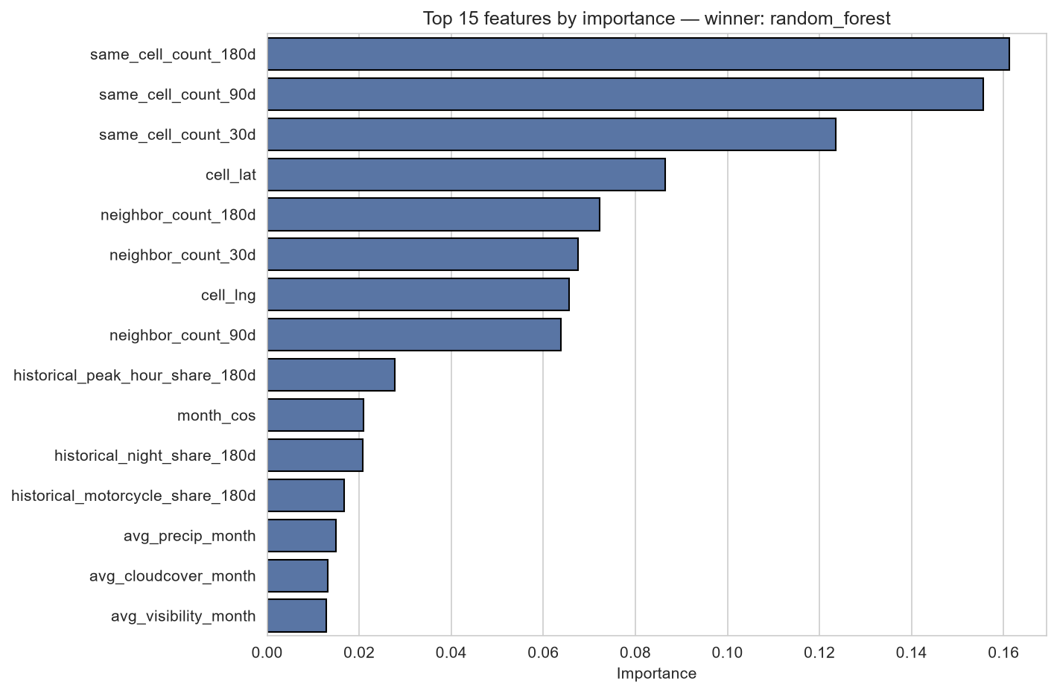
Figure 16 Random Forest Feature Importance for Hotspot Prediction (Top 15 Features)

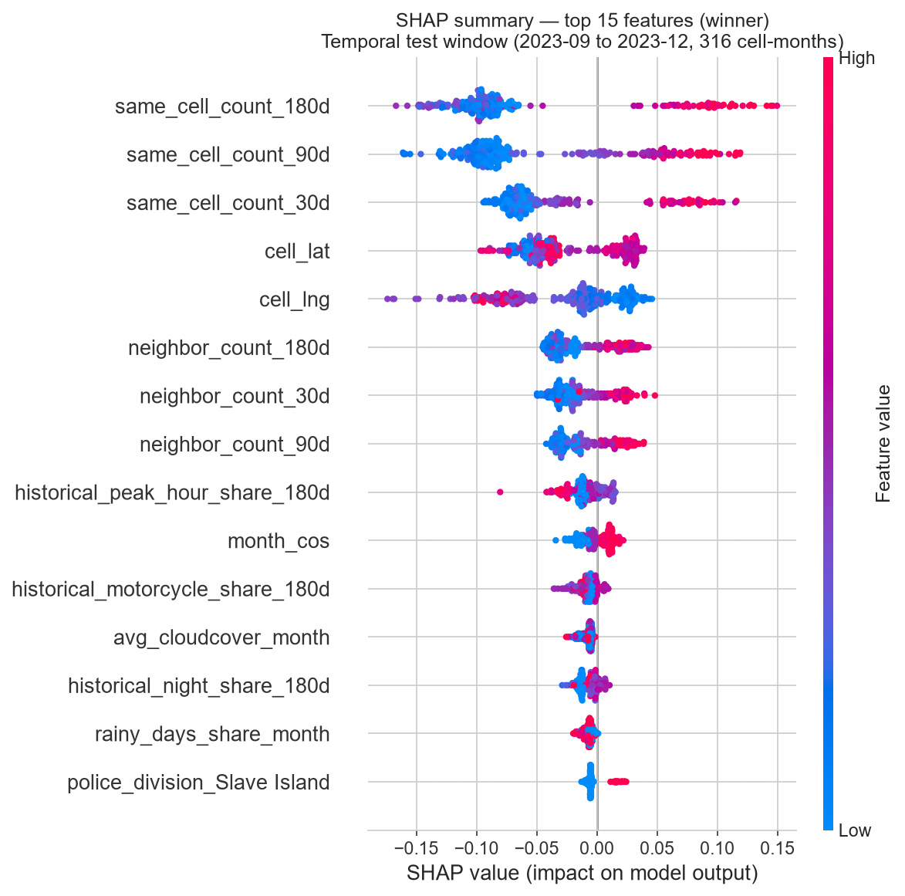
Figure 17 Summary Plot of the Random Forest Hotspot Classifier on the Temporal Test Window (September–December 2023)
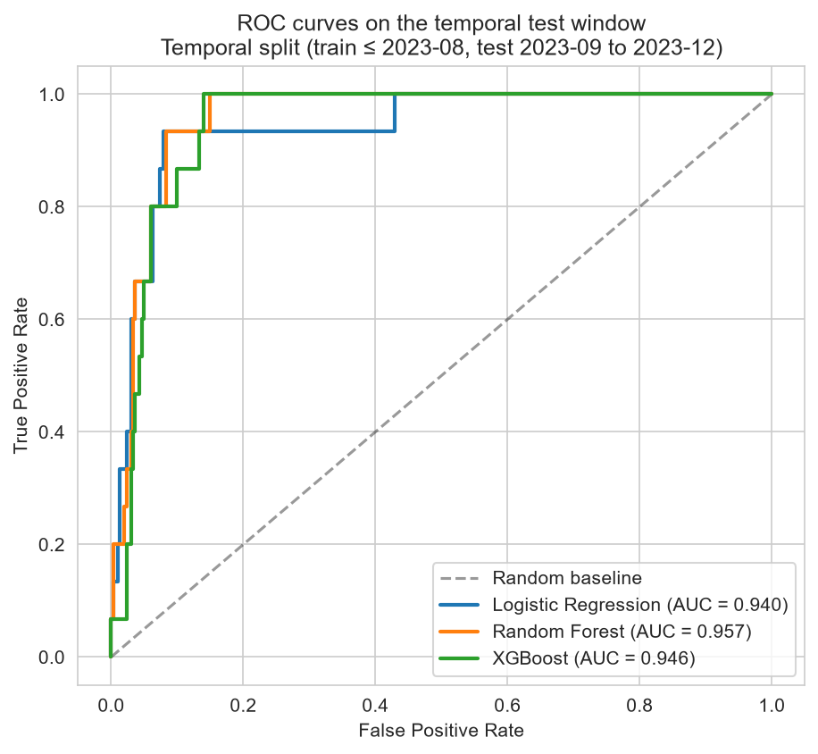
Figure 18 ROC Curves of the Hotspot Classifiers on the Temporal Test Window

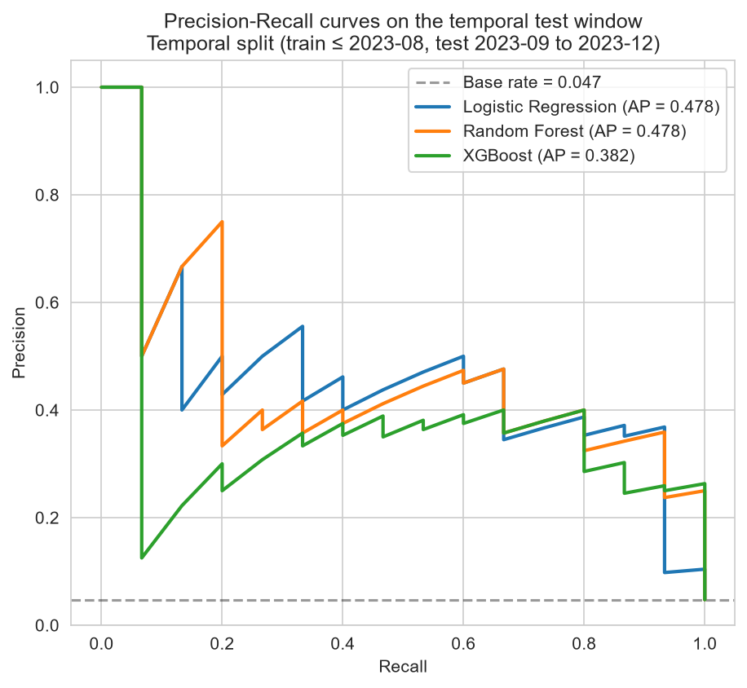
Figure 19 Precision–Recall Curves of the Hotspot Classifiers on the Temporal Test Window
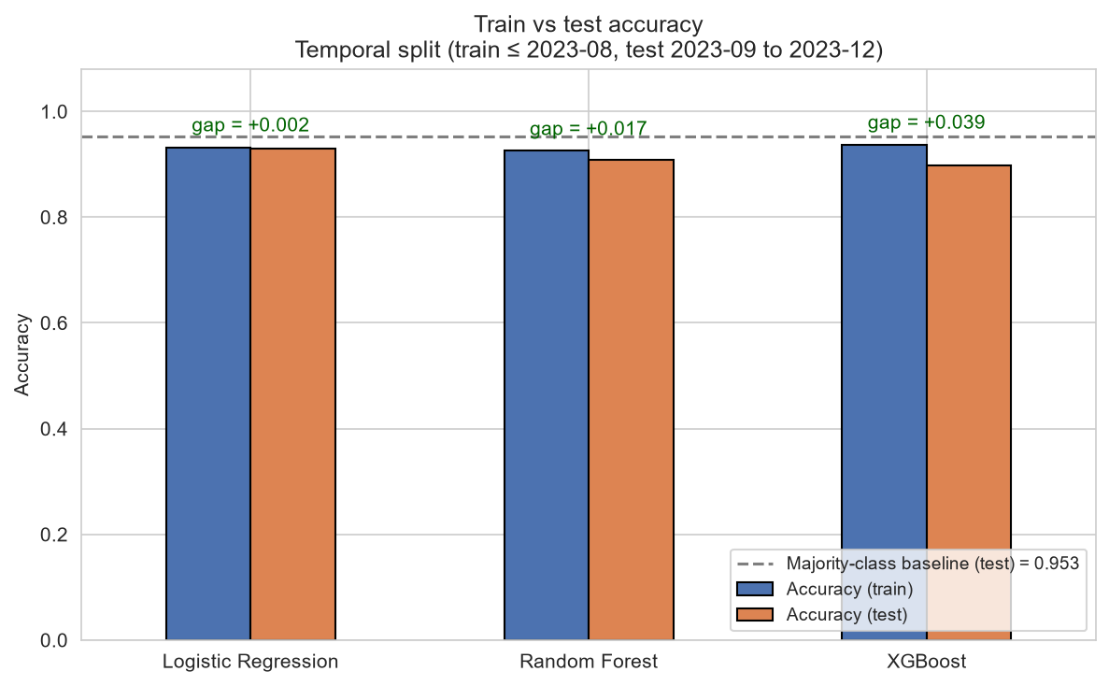
Figure 20 Train and Test F1-Score of the Hotspot Classifiers on the Temporal Split

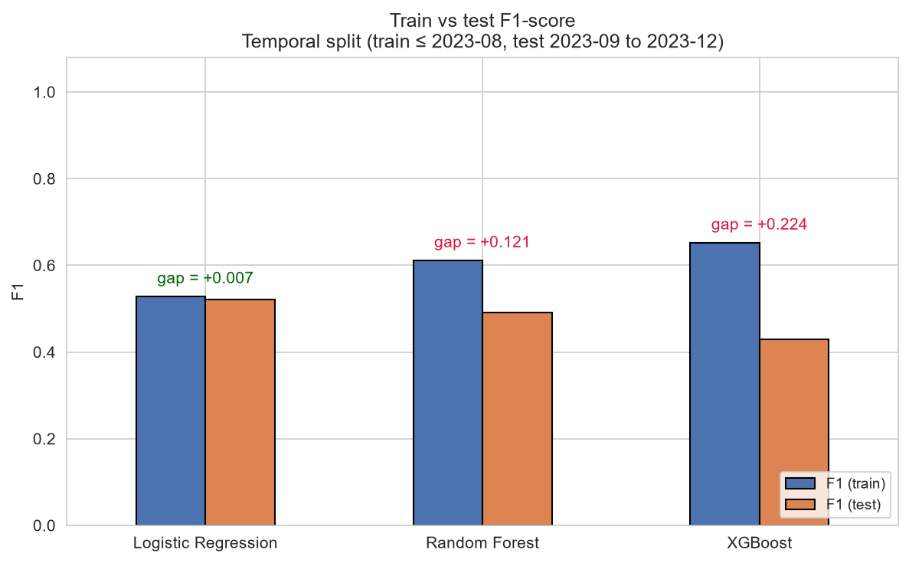
Figure 21 Train and Test Accuracy of the Hotspot Classifiers on the Temporal Split

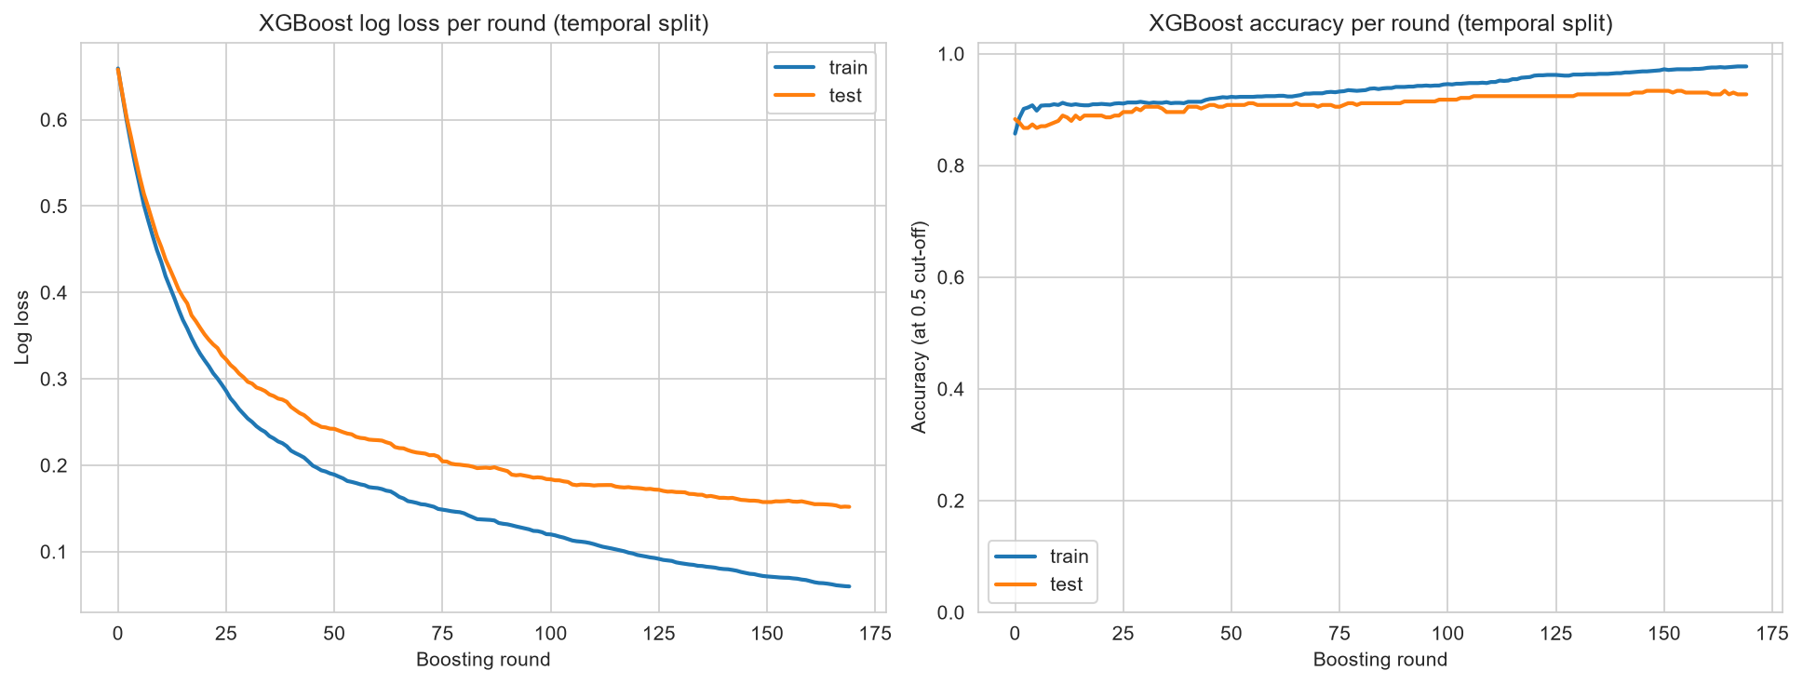
Figure 22 XGBoost Log Loss and Accuracy per Boosting Round on the Temporal Split

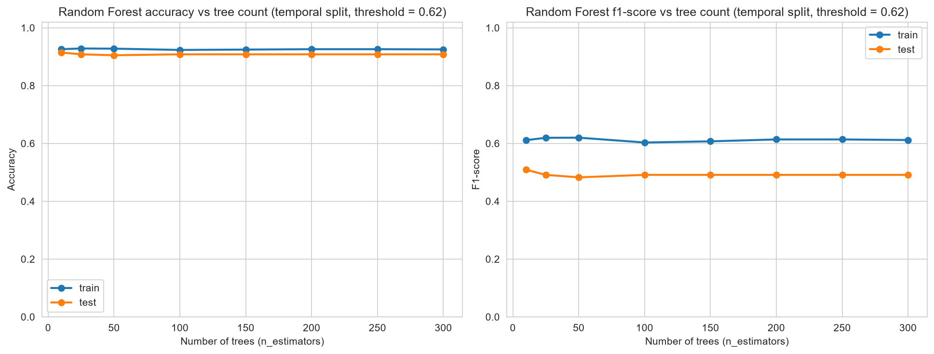
Figure 23 Random Forest Accuracy and F1-Score by Number of Trees on the Temporal Split

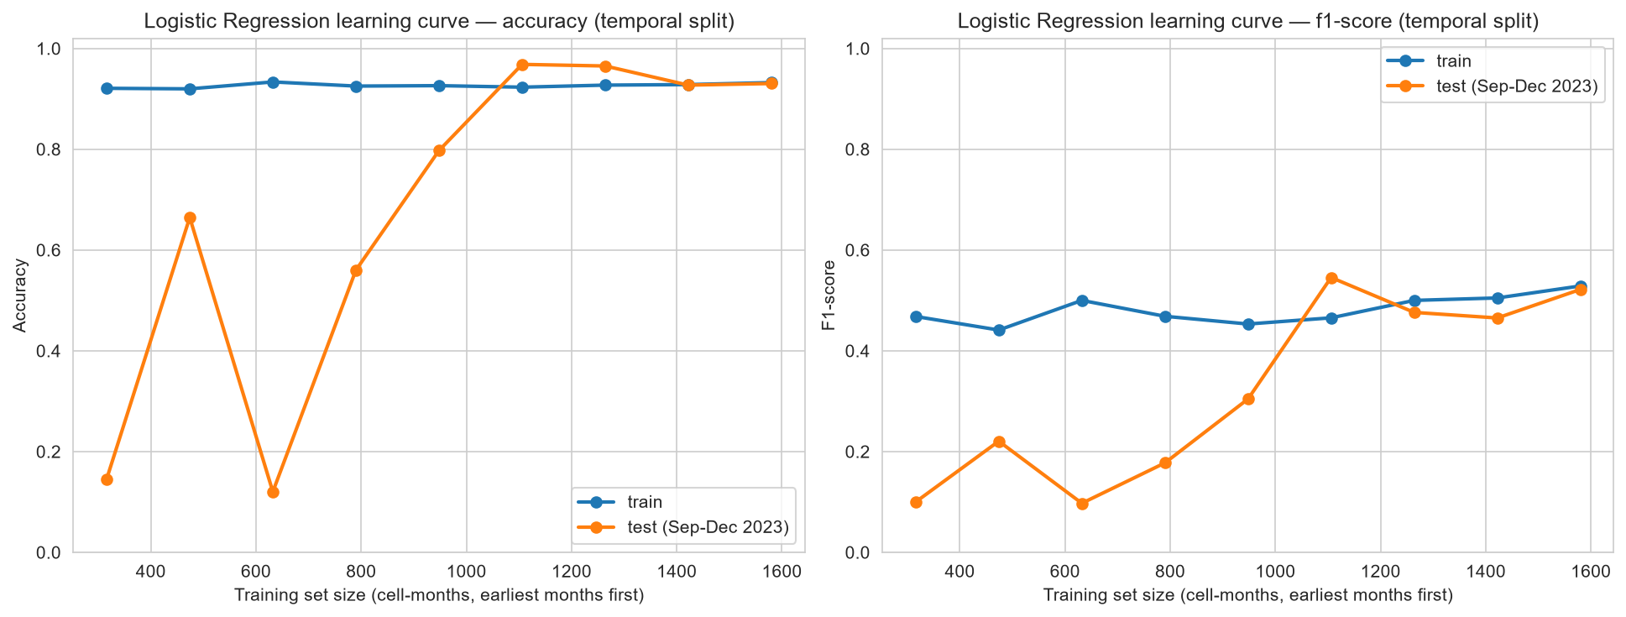
Figure 24 Logistic Regression Learning Curves on the Temporal Split (Expanding Monthly Training Window)

Appendix B – Severity Classifier Results

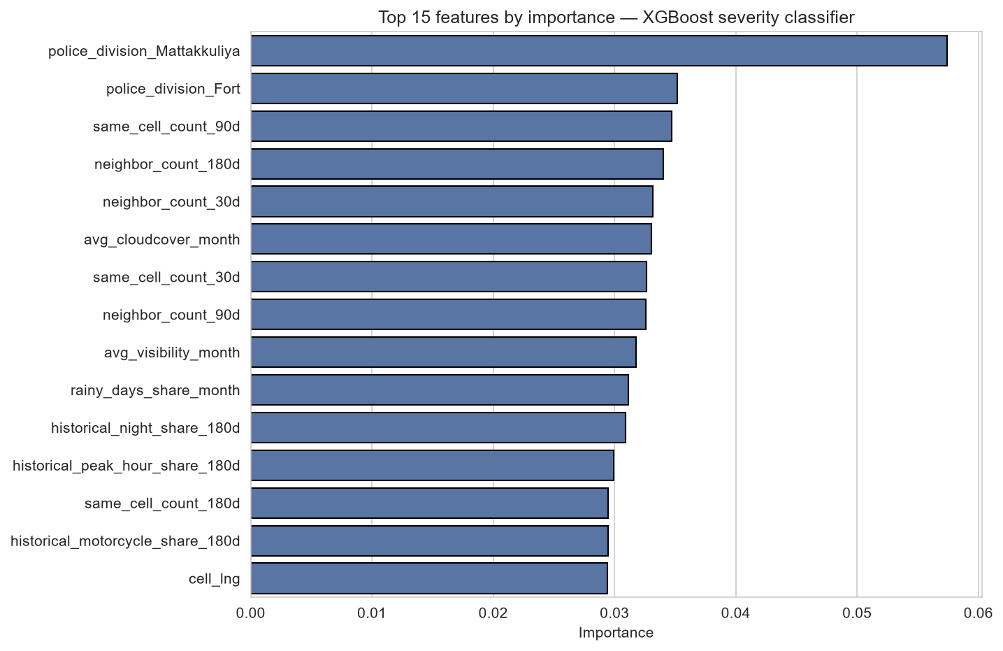
Figure 25 A11 XGBoost Feature Importance for Severity Classification (Top 15 Features)

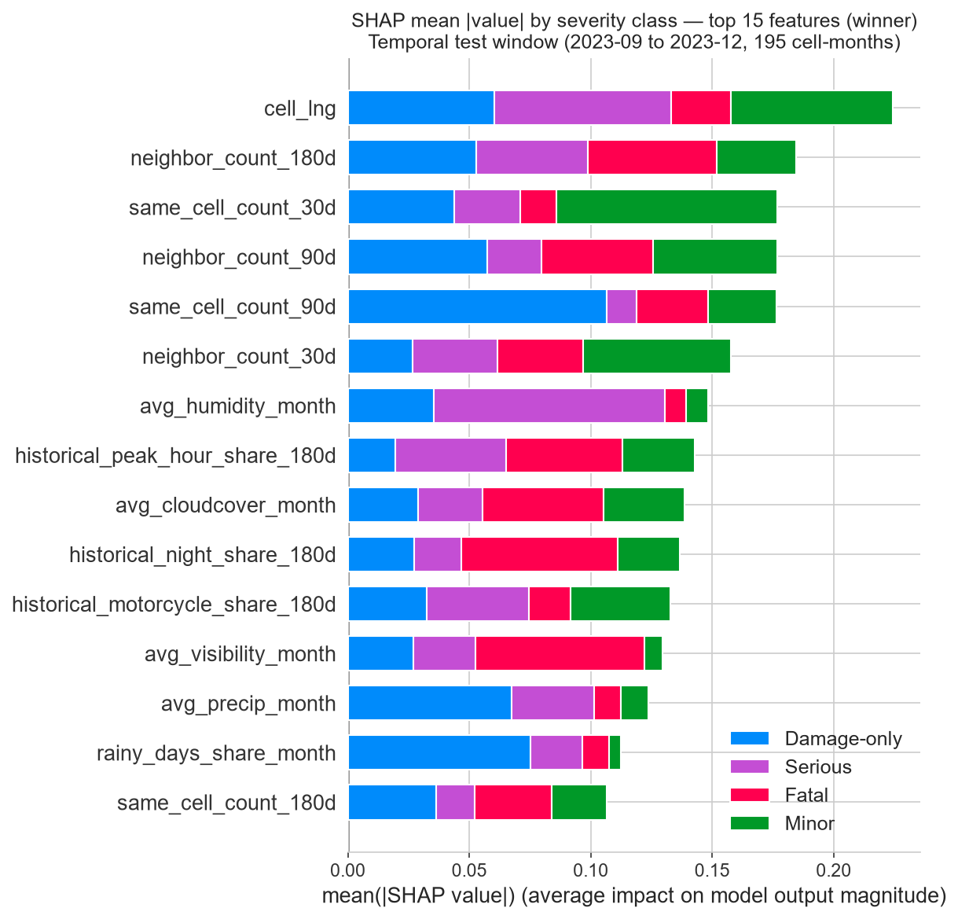
Figure 26 Mean Absolute SHAP Values by Severity Class for the XGBoost Severity Classifier on the Temporal Test Window
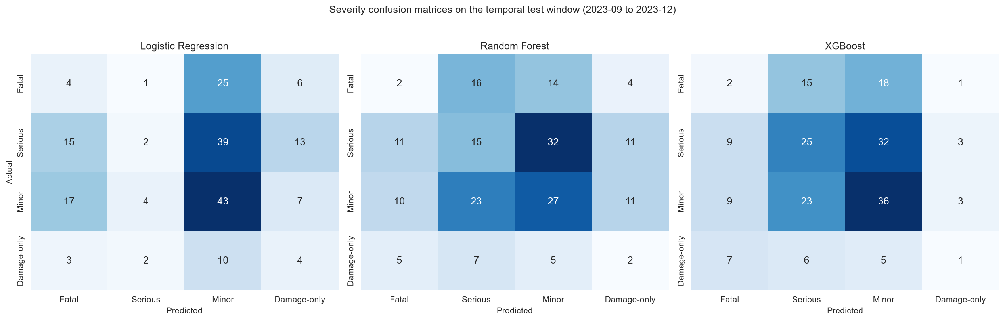
Figure 27 Confusion Matrices of the Severity Classifiers on the Temporal Test Window

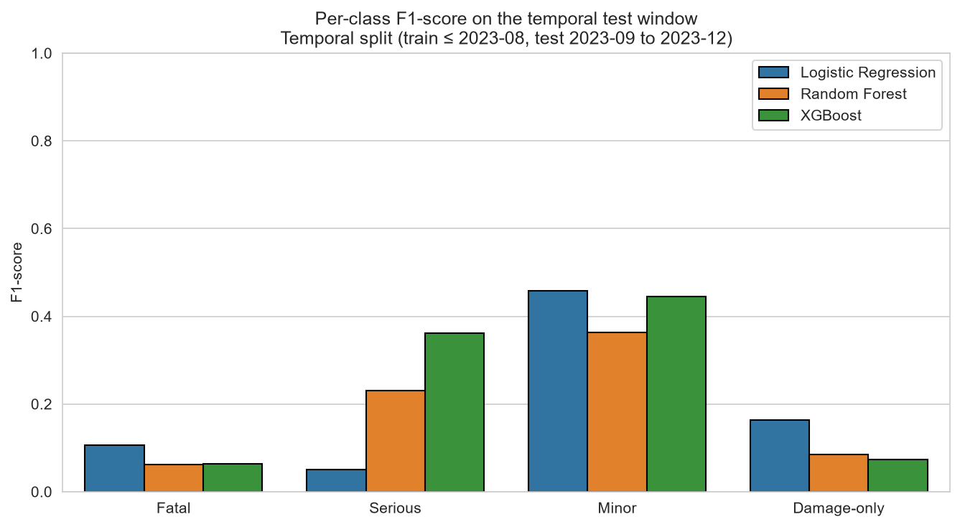
Figure 28 Per-Class F1-Score of the Severity Classifiers on the Temporal Test Window

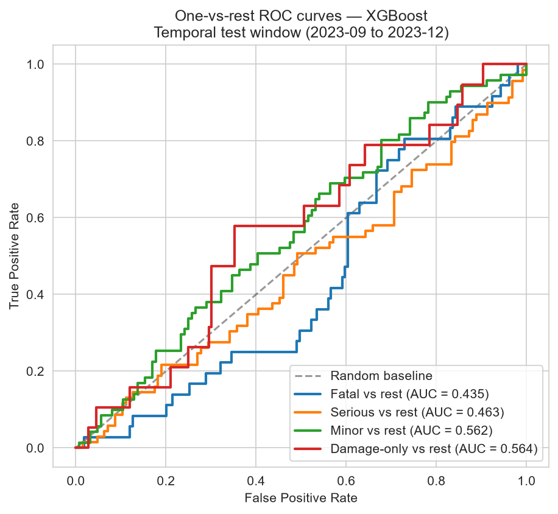
Figure 29 One-vs-Rest ROC Curves of the XGBoost Severity Classifier on the Temporal Test Window

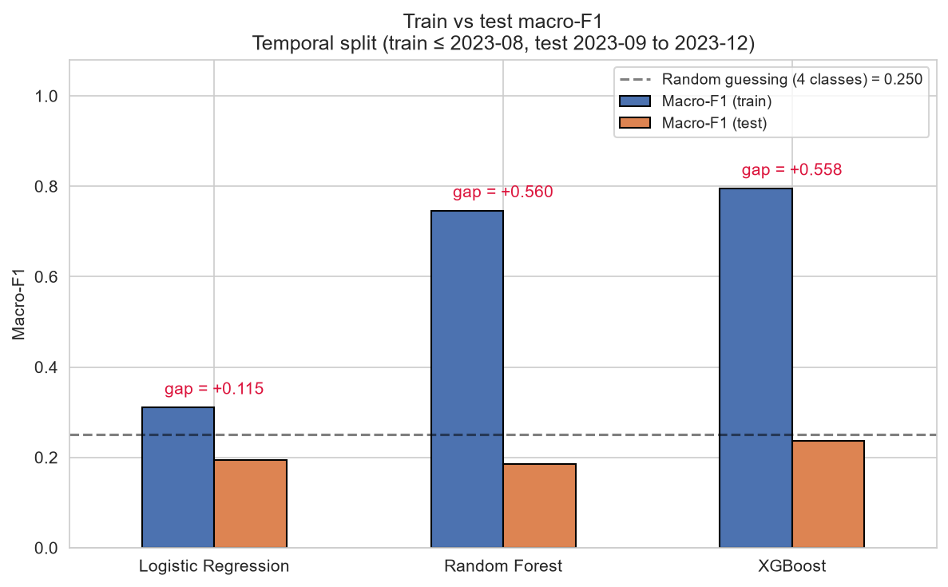
Figure 30 Train and Test Macro-F1 of the Severity Classifiers on the Temporal Split

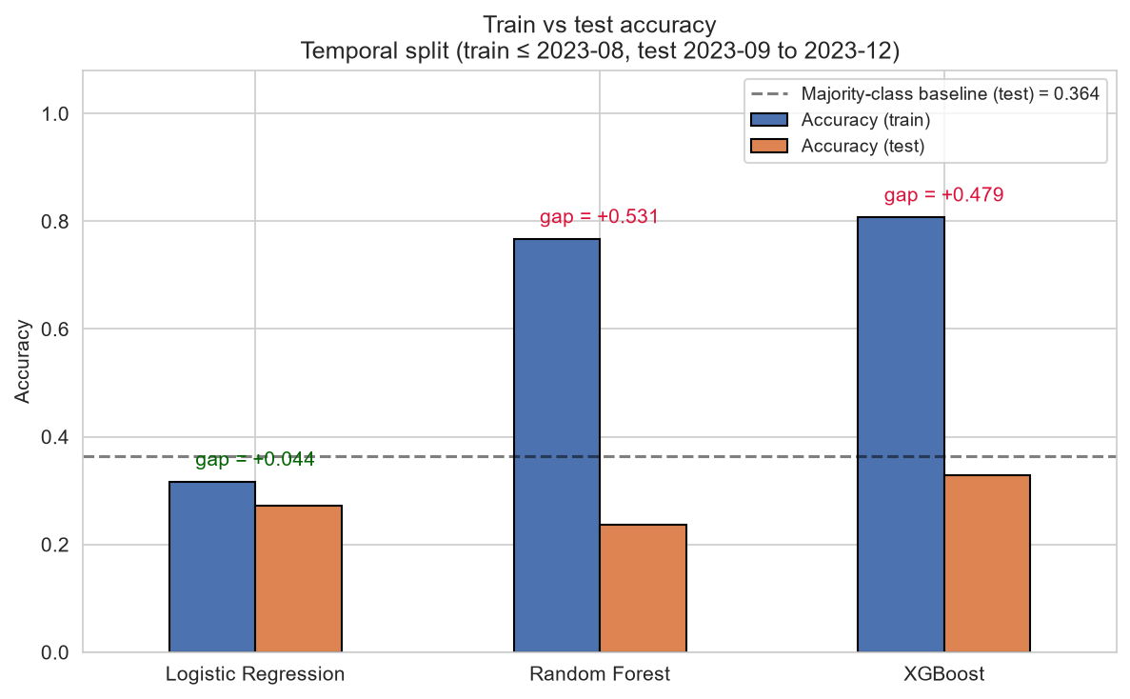
Figure 31 Train and Test Accuracy of the Severity Classifiers on the Temporal Sp

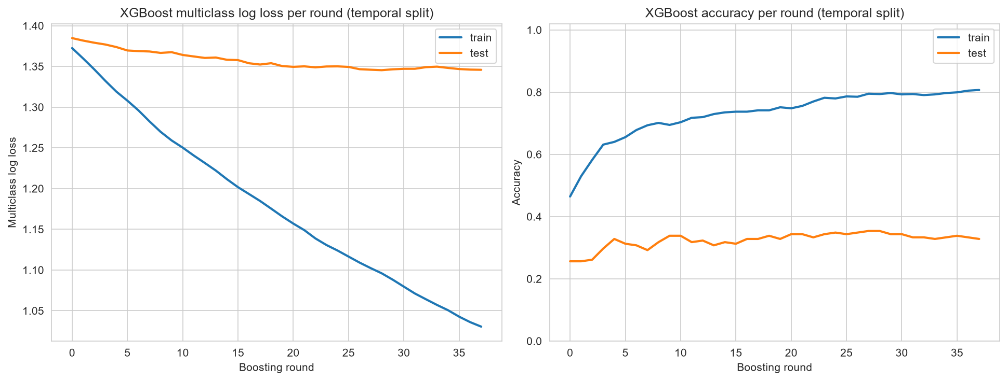
Figure 32 XGBoost Multiclass Log Loss and Accuracy per Boosting Round on the Temporal Split

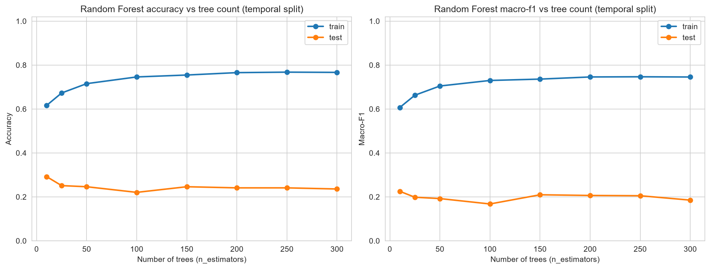
Figure 33 Random Forest Accuracy and Macro-F1 by Number of Trees for Severity Classification

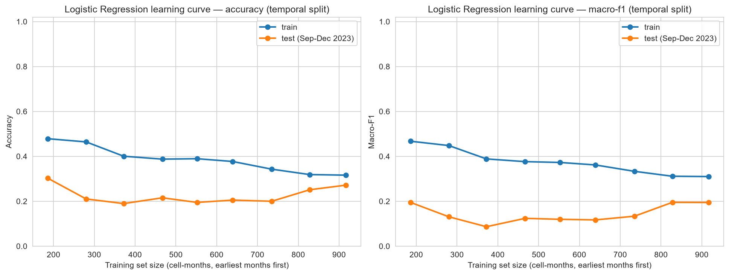
Figure 34 Logistic Regression Learning Curves for Severity Classification (Expanding Monthly Training Window)

Appendix C - Links
Detail | Link
GitHub Link (Framework) | https://github.com/NesaraRahal/XAI-Based-Traffic-Accident-Hotspot-and-Severity-Prediction/tree/main
GitHub Link (Dashboard) | https://github.com/NesaraRahal/-XAI-Based-Traffic-Accident-Hotspot-and-Severity-Prediction--Dashboard
GitHub Link (Dissertation and related documents) | https://github.com/NesaraRahal/-XAI-Based-Traffic-Accident-Hotspot-and-Severity-Prediction_Dissertation
Hosted Prototype Dashboard | https://xai-based-traffic-accident-hotspot-black.vercel.app/

